

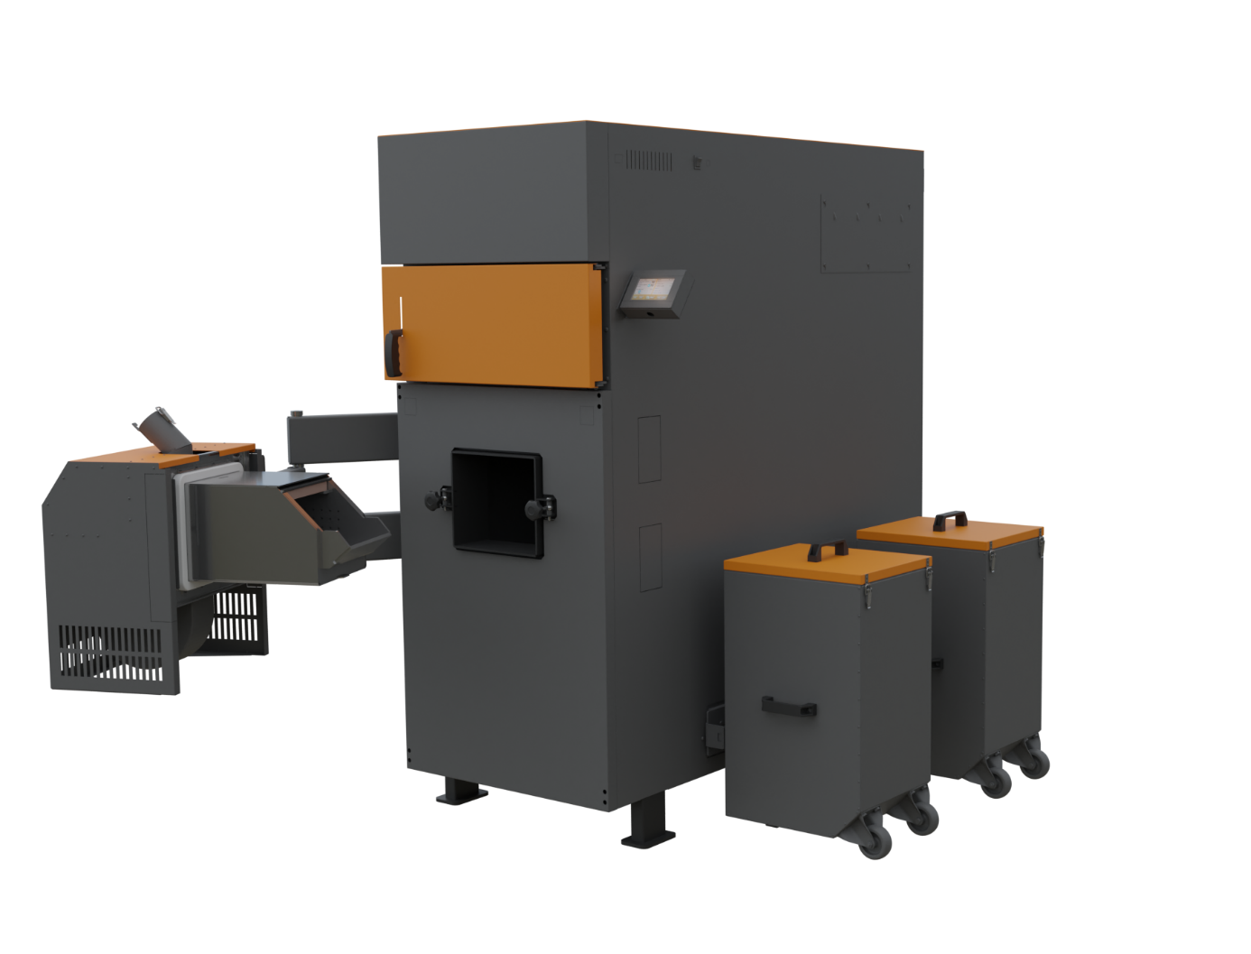

User manual
Biopel MINI 100,150,200

CONTENT
1. INTRODUCTION 4
2. BASIC CHARACTERISTICS OF BIOPEL MINI 100,150,200 BOILERS 4
3. MAIN PARAMETERS AND DIMENSIONS 5
3.1. Parameters of the Biopel MINI 100,150,200 boilers 5
3.2. Hydraulic losses of boilers 7
3.2.1. Biopel Mini 100,150,200 7
3.3. Burner 8
3.4. Hopper 8
3.5. External feeder 9
4. PRESCRIBED FUEL 9
5. BASIC ELEMENTS OF THE INSTALLATION CONFIGURATION AND PACKAGE CONTENTS 9
5.1. Biopel MINI 100,150,200 package contents 10
5.2. Burner 10
Package content: 11
5.3. External Hopper 11
5.4. External feeder 12
5.5. Automatic de-ashing 12
5.6. Compressor cleaning 12
6. INSTALLATION PROCESS 13
6.1. Boiler location 13
6.2. Display installation 15
6.3. Automatic de-ashing 15
6.4. Burner 16
6.5. External Hopper 19
6.6. External feeder 25
6.7. Compressor cleaning 26
6.8. Control unit 26
6.9. Electrical connection of accessories 28
7. BOILER CONTROL UNIT 31
7.1. Basic navigation 31
7.2. Basic operating modes 32
8. DESCRIPTION OF CONTROL UNIT FUNCTIONS 33
8.1. First start-up 33
8.2. Ignition / Extinction 33
8.3. Main settings 33
8.4. Installation menu 35
8.5. Service menu 43
8.6. Language selection 46
9. FIRST BOILER START-UP 46
10. COMBUSTION CORRECTION 47
10.1. Flame quality 47
10.2. Changing the fan speed 48
10.3. Changing the external feeder operating time 48
10.4. Non-standard installations 48
11. HEATING SYSTEM CONTROL 50
11.1. One CH circuit + DHW 50
11.2. Two CH circuits + DHW 50
11.3. One CH circuit with 4-way valve + DHW 51
12. Buffer tank size determination 51
13. REGULAR MAINTENANCE 52
14. BIOPEL ONLINE 52
15. FIRMWARE UPDATES 53
16. Risk analysis 53
17. OPERATING AND ERROR MESSAGES 55
18. TROUBLESHOOTING OF SPECIFIC SITUATIONS 56
19. FACTORY SETTINGS 59
20. ENERGY EFFICIENCY 61
21. IDENTIFICATION MARKS 62
22. WARRANTY CONDITIONS, GENERAL INSTRUCTIONS 65
23. APPLICABLE STANDARDS AND REGULATIONS 66
24. WARRANTY CARD 67

INTRODUCTION
For proper installation, start-up and operation of the Biopel MINI series boiler, we recommend reading this manual sequentially from chapter 1 onwards, following the chronological order so that none of the steps required for proper boiler operation are omitted during installation and commissioning. The chapters describe the installation, initial start-up, connection and activation of connected equipment and maintenance of the boiler. The manual describes each step gradually and adds practical information for each chapter to help the customer understand the operation of the boiler and the heating system control elements.
In the second half of the manual, you will find examples of the connection of heating systems and accessories, including a description of the settings in the control unit. In the event that one or more accessories are connected to the boiler, use this information to properly set up the accessory(s) so that operation is in accordance with this manual.
If you require any additional information regarding the operation of the boiler or boiler-controlled components, always feel free to contact a certified installation company or a representative of OPOP spol. s.r.o. directly.

BASIC CHARACTERISTICS OF BIOPEL MINI 100,150,200 BOILERS
The control system of these boilers allows to control all control elements of heating systems. The control unit is equipped with many advanced functions to ensure that the boiler is adapted to the customer's requirements. In addition, it allows the connection of many additional devices that simplify the boiler operation and add additional superior functions.
The control unit of the Biopel MINI boiler enables:
- Control of 2 mixing valves.
- Connection of 2 room thermostats to control 2 independent heating circuits.
- Connection of 5 pumps - central heating pump (ÚT), hot water pump (TUV), Valve pump 1, Valve pump 2, independently configurable pump.
- Compressor cleaning of the boiler burner and exchanger, which significantly prolongs the need for manual maintenance of the boiler and burner.
- Automatic de-ashing, pulling the ash out of the boiler into external containers, which extends the intervals between cleaning of the ash section of the boiler.
- Equithermal control based on outside temperature.
- Time control of boiler outlet temperature - programmable weekly operating mode.
- Heating of the buffer tank by means of 2 temperature sensors.
- Online control of all boiler functions and heating circuits via OPOP internet interface.
- Mobile app for iOS and Android phones, allowing remote management of the boiler and the entire heating system.
- Update the firmware of the control unit via USB interface to get new functions.
- DPCh - operational error detection. The unit displays error and operation messages on the main panel, which are also stored in the Main Settings, Activity History. By clicking on an operational error, you can view a detailed description of the problem and how to solve it.

In addition, the control unit of the Biopel MINI boiler allows the connection of a wide range of additional devices that automate boiler maintenance or provide new control options:
- RT10 room thermostat, displaying information about the entire heating system.
- Lambda probe, allowing automatic correction of the combustion process by measuring the residual oxygen in the boiler.
- S8-Wifi module, allowing control of the thermostatic heads of the radiators. Each room is thus heated as a separate zone with its own room temperature. This ensures optimum heat consumption and thus keeps heating costs to a minimum.
- Vacuum feeder which can transport pellets from the silo to the boiler hopper over long distances.
- Cascade controller, allowing you to control up to 4 boilers connected in series in one boiler room and use their power according to the current requirement of the heating system.

MAIN PARAMETERS AND DIMENSIONS
The main components of the basic configuration are the boiler, burner, feeder, automatic de-ashing and compressor cleaning. Below you will find the main parameters and dimensions of each of these components. When ordering, specify on which side the burner holder, display and feeder will be located. The pellet hopper is not included!

Parameters of the Biopel MINI 100,150,200 boilers
The boiler body varies in design according to its maximum output. The main differences are the external dimensions, the size of the connection sleeves and the shape of the heat exchanger

Technical parameters: |  | Biopel Mini 100 |  |  | Biopel Mini 150 |  | Biopel Mini 200
Nominal output | kW | 100 |  |  | 150 |  | 200
Minimum output | kW | 29 |  |  | 45 |  | 56.8
Guaranteed fuel | wood pellets 6-8 mm EN A1
Fuel consumption (at boiler nominal/minimum output) | kg/h | 22.56/6.71 |  |  | 34/9.9 |  | 46.1/13
Electrical input (max/min) | W | 128/61 |  |  | 180/84 |  | 220/100
Maximum electrical input | W | 580
Electrical input in standby mode | W | 4 |  |  | 4 |  | 4
Emission class*¹ | 5 / Ecodesign
Nominal/minimum power efficiency*¹ | % | 91.2/90,3 |  |  | 91.8/91,9 |  | 91.8/91.9
Water volume | l | 388 |  |  | 1042 |  | 1042
Operating stack draught (at nominal/minimum output) | Pa | 9/9.4 |  |  | 10 |  | 10
Maximum operating water pressure | Bar | 2
Heating water overpressure test | Bar | 4
Heating water temperature range | °C | 55 - 85
Minimum return water temperature | °C | 55
Flue gas temperature  (at nominal/minimum output) | °C | 138.5/92,2 |  |  | 115.5/67,2 |  | 125.2/77.7
Flue gas mass flow rate (at nominal/minimum output) | Kg/s | 0.0604/0.0295
Weight | kg | 848 |  |  | 1600 |  | 1600
Connection voltage | V/Hz | 230V/50Hz ±10%
Boiler noise/ Noise of compressor cleaning | dB | 62.6 / 93 |  | 62.6 / 93 |  |  | 62.6 / 93
Cover of the device |  | IP21
Hydraulic loss at DT = 20/10 K | mbar | 12.2/51.5
A fan is used for heating |  | YES
Boiler operation |  | Overpressure at the flue gas outlet
Operation with flue gas condensation |  | NO
*¹ Emission values and classes are determined by tests performed in test institutes subject to the standard ČSN EN 303-5+A1.
Dimensions: |  | Biopel Mini 100 | Biopel Mini 150 | Biopel Mini 200
Boiler height [A] | mm | 1691 | 1704 | 1704
Boiler width [B] | mm | 695 | 1095 | 1095
Boiler depth [C] | mm | 1671 | 2360 | 2360
Flue diameter | mm | 200 | 200 | 200
Position of the centre of the flue pipe from the ground [D] | mm | 1313 | 1413 | 1413
Location of the inlet water sleeve from the ground [E] | mm | 196 | 196 | 196
Location of the outlet water sleeve from the ground [F] | mm | 1611 | 1611 | 1611
Boiler depth including burner cover [H] | mm | 1885 | 2661 | 2661
Height of burner cover [I] | mm | 495 | 495 | 495
Burner cover depth [J] | mm | 212 | 300 | 300
Width of boiler including accessories [K] | mm | 1480 | 1794 | 1794
Location of the outlet water sleeve from the flue pipe [L] | mm | 952 | 1646 | 1646
Location of the outlet water sleeve from the side of the boiler [M] | mm | 347.5 (B/2) | 548 (B/2) | 548 (B/2)
Inlet and outlet water connection sleeves | palce | G 1 ¼  (inner thread) | G 1 ¼  (inner thread) | G 1 ¼  (inner thread)
Connection for discharge and filling | palce | G1/2  (inner thread) | G1/2 (inner thread) | G1/2  (inner thread)
Boiler body wall thickness (water/flame) | mm | 5 | 5 | 5
Boiler body wall thickness (water) | mm | 3 | 3 | 3
Heat transfer surface | m² | 8.1 | 17.5 | 17.5

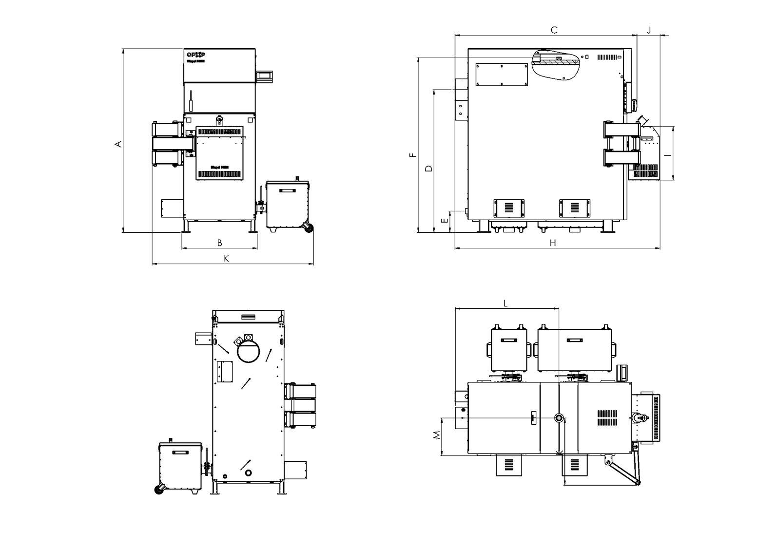

Hydraulic losses of boilers

Biopel Mini 100,150,200

∆t =10°C | Water flow through the boiler | m³/h | 8.571
∆t =10°C | Hydraulic loss of the boiler | mbar | 51.5
∆t =20°C | Water flow through the boiler | m³/h | 4.286
∆t =20°C | Boiler hydraulic loss | mbar | 12.2

Burner
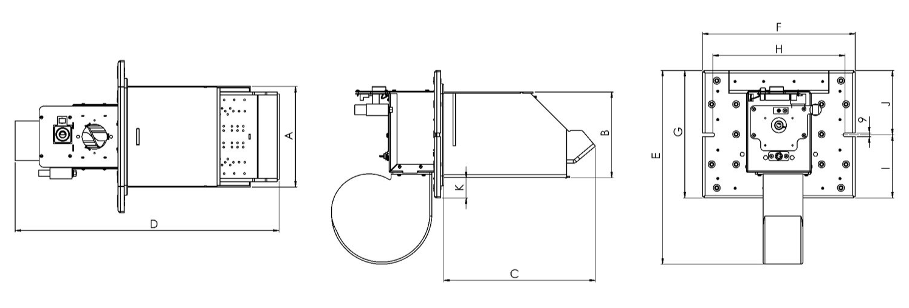
The pellet burner, like the boiler, differs according to its maximum output. The differences are in the size of the burner, the choice of electrical components, the shape and size of the grate, the thickness of the material used.

Dimensions mm | Biopel Burner 100 | Biopel Burner 150 | Biopel Burner 200
A | 248 | 339 | 339
B | 211 | 224 | 224
C | 373 | 527 | 527
D | 649 | 845 | 845
E | 477 | 477 | 477
F | 375 | 453 | 453
G | 314 | 298 | 298
H | 325 | 412 | 412
I | 155 | 147.5 | 147.5
J | 158 | 150.5 | 150.5
K | 50 | 37 | 37

Hopper
Hoppers are divided according to their dimensions. Hoppers and boilers can be freely combined with each other. In the manual and in the boiler control unit you can find two names, namely Hopper or Pellet hopper.
Type of hopper | cm | External 80x80 | External 100x100 |  | External 1420x80 | External 3t | External 5t | External 10t
Volume of pellets | kg | 220 | 300 |  | 350 | 2500 | 4200 | 8700
Weight | kg | 25 | 29 | 35 |  | 370 | 563 | 865
Height [C] | mm | 1300 | 1300 | 1300 |  | 2005 | 2710 | 2710
Width [A] | mm | 600 | 815 | 1000 |  | 2130 | 3260 | 3260
Depth [B] | mm | 600 | 815 | 1000 |  | 2130 | 1575 | 3260

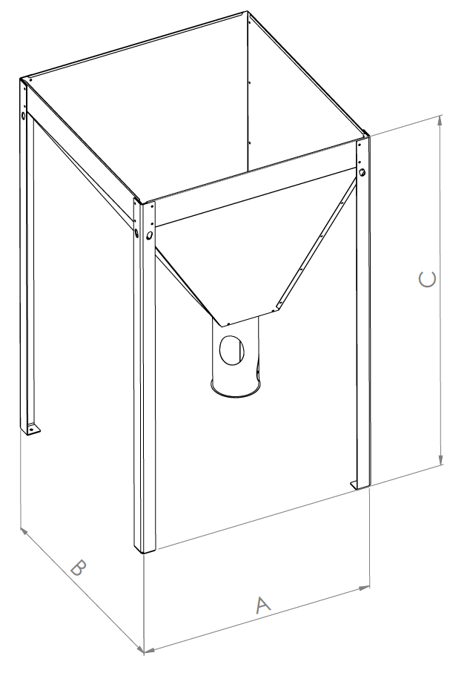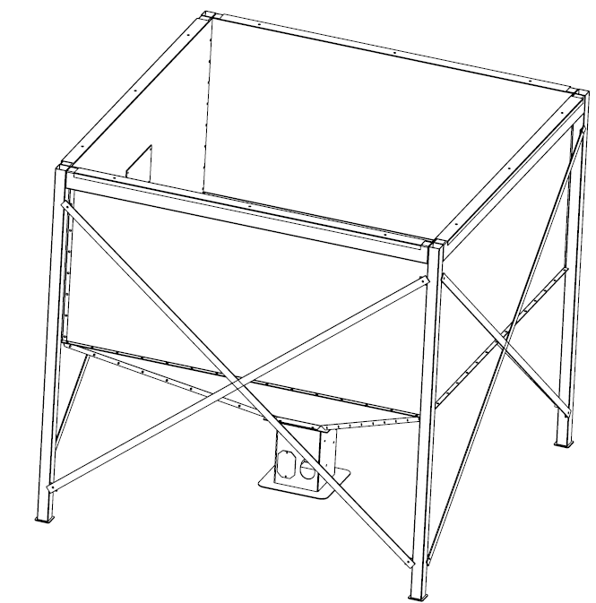

External feeder
The external pellet feeder is only used in the case of a configuration with an external hopper version. The compact pellet hopper is already equipped with a feeder from the factory. You can choose between two sizes of external feeder - 2 or 3m.
Type of external feeder | m | 2 | 3

PRESCRIBED FUEL

Fuel | Fuel type | Grain size [mm] | Calorific value [kJ/kg-1]
Wood pellets | EN plus A1 | 6 | 16,5-19,5
  - Water content in fuel: max. 10%
  - Low caking properties
  - Low swelling

Only use pellets that comply with ENplus1 for heating in the Biopel MINI boiler. The pellets must be made from wood only. The lower the bark component in the pellet, the higher the quality of combustion you can expect with a minimum amount of ash.

BASIC ELEMENTS OF THE INSTALLATION CONFIGURATION AND PACKAGE CONTENTS
Biopel MINI is manufactured in three sizes according to the maximum boiler output, namely 100, 150, 200kW. Each boiler size has its differences not only in terms of external dimensions, but also in the design of the boiler heat exchanger, doors and connection sleeves. Furthermore, the boiler size influences the type of pellet hopper, pellet feeder, burner dimensions, etc. Below are the basic parameters of all these elements of the complete Biopel MINI set.

Biopel MINI 100,150,200 package contents
The boiler is equipped with two cleaning doors, one at the front and the other at the top of the rear under the cover. The top cleaning door is attached with a star handle and is on a hinge for better access and cleaning of the boiler heat exchanger.
The burner (burner opening) is located under the front door. Further, at the rear of the side covers you will find openings for the attachment of the automatic exchanger cleaner (an additional device) as well as shaft leading the cabling from the unit to the rear part of the boiler.
In the rear part of the boiler you will find 2 inlet sleeves for the inlet water to the boiler and a fill and drain sleeve. At the top of the boiler (approximately in the middle) there is the outlet water sleeve. Next to the outlet water sleeve there are the pits for the temperature sensors (central heating /ÚT/ sensor and Termic sensor). On the rear cladding of the boiler you will find a cap next to the flue pipe that covers the Lambda probe and flue gas temperature sensor pit. The flue connection outlet is located in the rear, central part of the boiler.

Temperature sensors (central heating /ÚT/, Termic and flue gas sensors) are led to the upper part of the boiler through the side shaft for cabling and connected to the respective pits.
The hinges of the control door can be mounted on the opposite side of the boiler. Refitting the ash door hinges is necessary to ensure that the ash door can be opened without problems.
The hinges of the control door can be attached to the boiler from the left or the right, according to the customer's needs. The ash door can be therefore installed from the left or the right.
Outside the boiler there are 2 ash containers into which the ash is removed by means of a worm (automatic ash removal). We recommend checking the ash quantity once a week. Inside the boiler, in the exchanger part of the boiler, there are so-called flue gas swirlers, which reduce the flue gas temperature in the chimney and thus increase the efficiency of the boiler. Cleaning of the flue gas swirlers is ensured by automatic compressor cleaning.

Burner
The pellet burner differs according to its power, the type of grate and the type of electrical components used in the burner. The maximum output of the burner is also indicated by its external dimensions. The burner is equipped with the following components:
- burner skeleton,
- internal pellet feeder (motor and worm),
- fan,
- ignition cartridge,
- photosensor,
- safety temperature sensor,
- burner circuit board,
- removable grate,
- the asbestos sealing cord,
- burner cover.
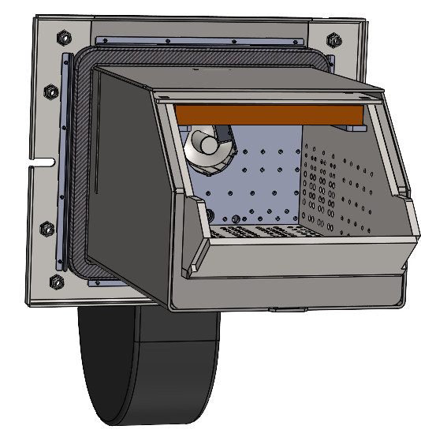
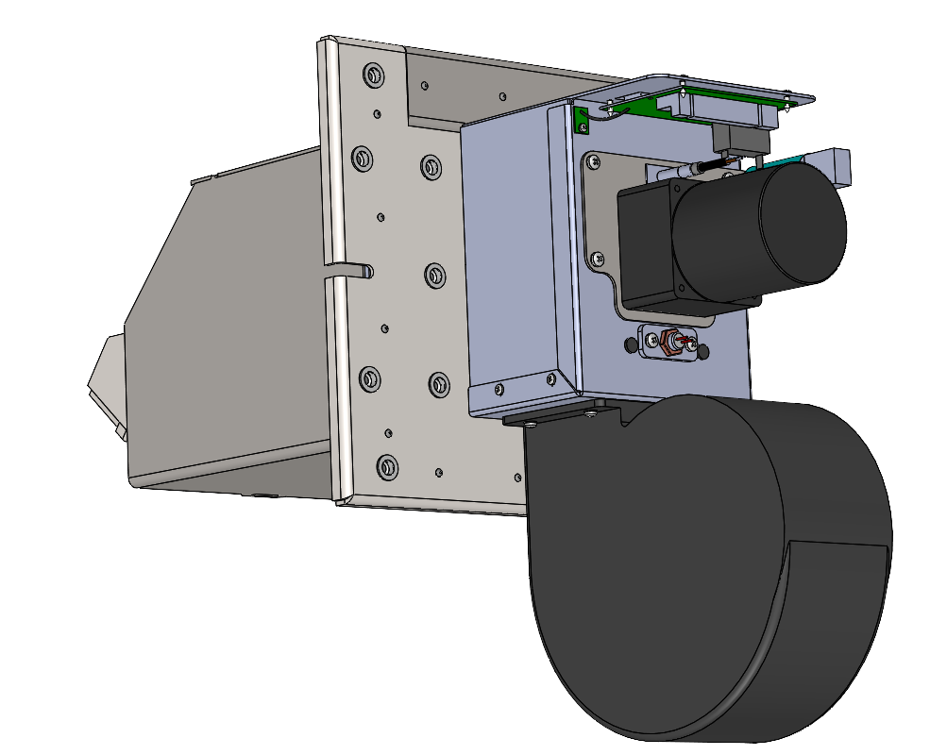
i
h
g
f
e
d
c
b
a

At the top there is a hole for connecting the burner tube with three holes for fixing the tube with screws. Next to this hole you can find 2 connectors for connecting the burner to the control unit. The smaller connector transmits the signal from the photosensor and the safety temperature sensor. The large connector transmits 230V voltage to control the burner's electrical components (fan, internal feeder motor, ignition cartridge). The fan and the internal feeder motor are each connected to a separate start-up capacitor, which are also located on the burner body.
The burner body and grate are made of heat resistant stainless steel to withstand high combustion temperatures of up to 1,100°C. The burner grate is removable and requires regular cleaning. The holes in the burner grate must be permeable for maximum combustion efficiency.

The ignition cartridge and the asbestos sealing cord are subject to wear. It is necessary to replace them at regular intervals.
The ignition cartridge ensures automatic ignition of the pellets, which normally takes 3 to 5 minutes. The resulting flame is detected by a photosensor, which ensures the transition from the automatic ignition phase to normal operation. The photosensor, together with the flame safety sensor, also serves to ensure operational safety and is responsible for shutting down the burner in the event of sudden extinction (the photosensor is responsible) or overheating of the burner (the temperature safety sensor).
The asbestos sealing cord must always fit tightly against the boiler or the burner flange on the boiler so that smoke and heat from the joint does not escape into the room. Otherwise, combustion fumes would leak into the room and there would be a risk of damage to boiler components and a risk of fire.
The burner is the heart of the boiler and requires regular maintenance of its components, especially the grate. The burner is removable by means of an arm mechanism for more convenient cleaning. Ensure that the grate is correctly placed back into the burner so that it cannot move or fall out. For more information on cleaning and handling the burner, see the chapter Regular maintenance.

Package content:
- Burner 100,150,200 kW
- Control unit v9 display
- Burner cover
- Burner tube – for connection to the burner
- 7pcs screws M8x10, for attaching the burner flange to the arm mechanism
- Sealing ring - for sealing the connection between the burner hole and the feeder tube
- PVC hose - to connect the burner to the external feeder
- 2 star clips - for mounting the burner to the boiler

External Hopper
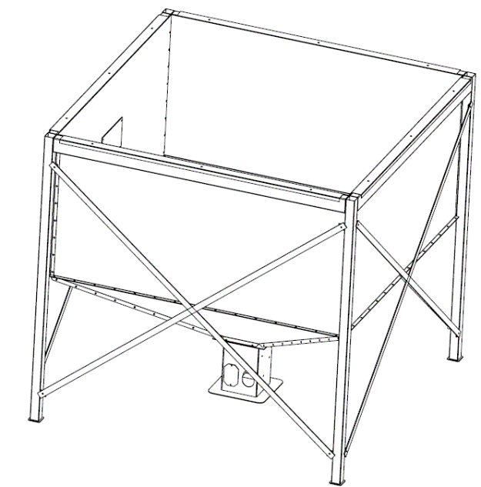
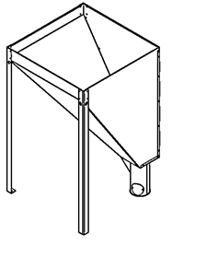
The external hopper can be combined with all boiler sizes. This is assembled on site and comes from the factory in a disassembled state. For a description and installation diagram, please refer to the Installation Procedure section of this manual.
b
a
c
a
b
c
- Main hopper legs - attached at the top to the hopper
- Leg for inserting the External Feeder. There is a hole in the leg into which the feeder is inserted
- Filling hole - can be fitted with a lid

External feeder
The external pellet feeder is used to transport pellets from the external hopper to the burner. It is only installed when installed with the external hopper, as the compact version of the hopper already has this feeder integrated inside. The feeder is equipped with a motor whose speed varies according to the size of the boiler. Check the label on the external feeder to see which boiler capacity this feeder is designed for. Only use the type of external feeder that is designed for your boiler size.
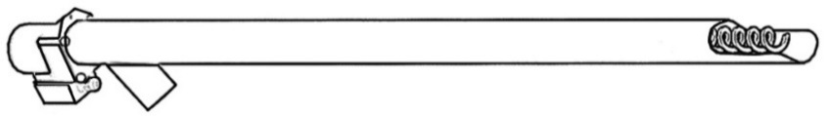
d
a
b
c
e
f

- Feeder motor with capacitor – the bigger the boiler, the faster the motor
- PVC feeder pipe
- Feeder sworm
- Input of pellets into the feeder
- Output of pellets from the feeder to the burner
- 230V socket - for connecting the external feeder to the external socket on the boiler

Automatic de-ashing
The automatic de-ashing is supplied in a disassembled state and must be installed at the boiler installation site. It consists of 3 main parts: motor with a worm, ash container, flange for attaching the container.
The package includes:
- 2 pcs automatic de-ashing container with lid
- 2 pcs flange with ash door lock and gasket
- 2 pcs worm with motor, connecting parts and seal
- 2 pcs motor cover
- 2 pcs power cable

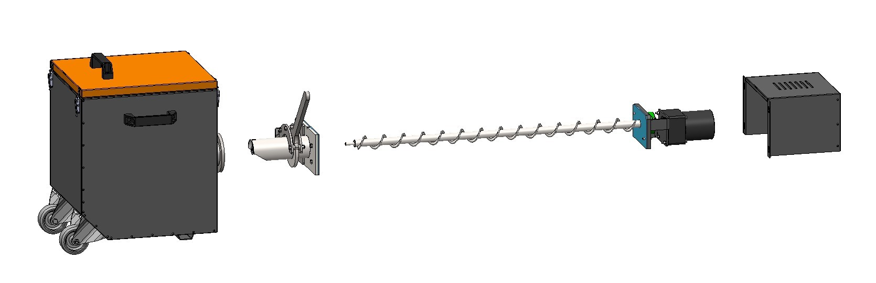
a
b
c
d

Compressor cleaning
Compressor cleaning of the burner and heat exchanger is carried out by means of a compressor. Tubing is connected to the compressor so that the compressed air is delivered to the burner and exchanger. This air is then introduced by means of solenoid valves which are controlled by the boiler control unit. The valves open independently of each other according to the settings in the boiler control unit.
The following parts can be found in the compressor cleaning package for the burner and boiler exchanger:
- 1pc compressor
- 4pcs small heat exchanger tubes
- 4pcs of exchanger tubes large
- 4pcs elbow for connection of small and large exchanger pipe
- 4 pcs exchanger tube nut (fixing from the outside of the weldment)
- 3pcs solenoid valve (1x for burner cleaning, 2x for exchanger cleaning)
- 3pcs connecting cable (for connecting the solenoid valve to the external socket on the boiler)
- 6pcs fasteners for 6mm cables
- 6m polyurethane hose, D8, 0.8MPa
- 6m polyurethane hose, D12, 0.8MPa
- 2pcs burner cleaning tubes
- 2 pcs of plastic strapping (for fixing the burner cleaning pipes)
- 1pc sleeve brass T-piece G1/2"
- 1pc reducer outer G1/2" - outer G1/4"
- 5pcs socket coupling, straight, 12mm, G3/8", INNER THREAD
- 1pc reducer external G1/2" - external G3/8"
- 3pcs socket coupling U, 12mm
- 1pc socket coupling U, 8mm
- 2pcs 90° angle couplings, single, 8mm

INSTALLATION PROCESS
The whole installation process can be divided into the following stages:
- Unpack the boiler from its packaging. Remove the covering transparent film and place the boiler in its intended final position in the boiler room. Please note the following when handling the boiler:
  - The boiler must be placed on a level floor or pedestal so that it is in a horizontal position. Tilting the boiler is not possible. (note the legs are not adjustable!)
  - Check in advance that there is sufficient space in the boiler room to open the control door, the cleaning door, insert the automatic de-ashing worm (the worm is 1.1m long) and the automatic de-ashing worm (see section 6.1)
- Installation of the boiler
- Installation of the automatic de-ashing system
- Installation of the burner, hopper and feeder
- Compressor cleaning
- First start-up of the boiler
- Calculation of the external feeder output in case of non-standard installation
- Combustion correction
- Adjustment of other functions and correction of the operation of additional devices

Boiler location
The boiler must be installed in a separate boiler room specially adapted for heating. The boiler room must have sufficient space for the installation and maintenance of the boiler. Adequate fresh air circulation for combustion must be provided, the chimney design must ensure adequate draft for the type of boiler concerned and must comply with the construction criteria set out later in this manual and in the mandatory regulations. The boiler must never be installed in open spaces or balconies, in areas occupied by people, such as the kitchen, living room, bathroom, bedroom, in areas where explosive and flammable materials are present.
Install the boiler on a concrete base made of fireproof material or on a fireproof pad.
The safety distance must also be doubled if the degree of flammability of the building material is not proven.

Minimum installation distance from walls:
 |  | Biopel Mini 100,150,200 kW
A | mm | 500
B | mm | 900
C | mm | 1300
D | mm | 1700

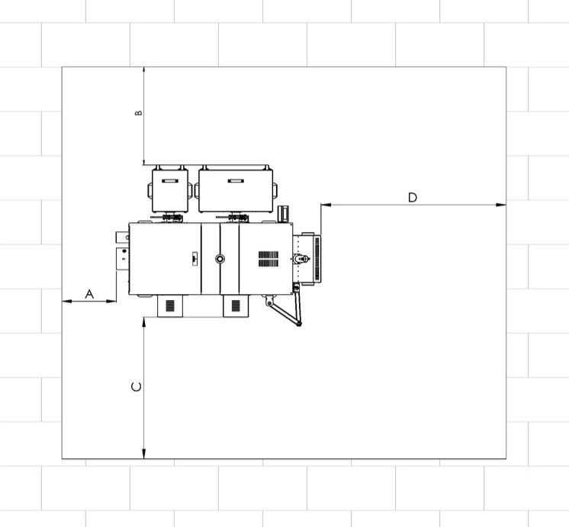

There should be at least the clear space around the boiler visible in the picture. When installing and operating the boiler, a safe distance of 200 mm from combustible materials of flammable class B, C1 and C2 (according to ČSN 06 1008) must be observed.
The safety distance is doubled for flammable materials of flammability class C3 which burn quickly and burn themselves even after the ignition source is removed (e.g. paperboard, cardboard, asphalt and tar board, wood and fibreboard, plastics, floor coverings), i.e. to 400 mm.
The flue pipe fixed in the flue and fitted to the flue neck of the boiler must be firmly assembled and fitted to prevent accidental or spontaneous loosening. It is recommended that the flue pipe from the boiler to the chimney should be no more than 1 m long and should rise towards the chimney; a slope of at least 5% (3°) is recommended. Connection is recommended straight - no more than one bend.
The boiler and flue must comply with the fire regulations of ČSN 06 1008:1998 (Fire safety of thermal equipment), ČSN EN 13501-1:2019 (Fire classification of construction products and structures of buildings - Part 1: Classification according to reaction to fire test results).

Display installation

The display is located on the side of the boiler (left or right). The mounting process is as follows:
- Pull out the cable hole in the side cover (a) if not present.
- Screw on the display bracket (b) with two M5 screws (c).
- Using two more M5 screws (c) and two nuts, screw on the display bezel (d)
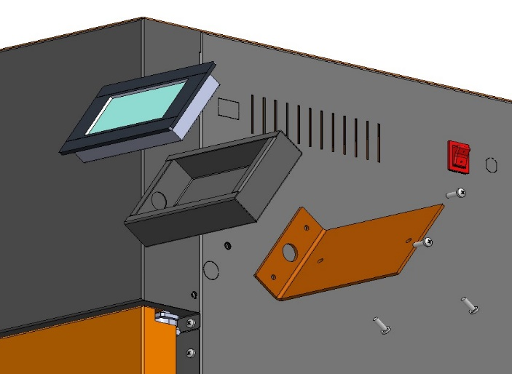
- Carefully pull the cable from the outside through the hole, plug into the display (e) and insert the display into the bezel.
c
b
c
e
d

Automatic de-ashing

Automatic ash removal, pulling the ash from the boiler into an external container. Before installation, it is necessary to clarify from which side we want to have ashtrays installed. The containers must be secured with a lever after insertion to prevent them from rolling away!
Follow the steps below for proper installation and activation of the device.
- Unpack all necessary parts
- Insert the worm with motor (a) into the hole together with the seal (b)
- Screw in with two M6 screws (c) so that the flange fits and seals
- Connect the motor electrical connector (d)
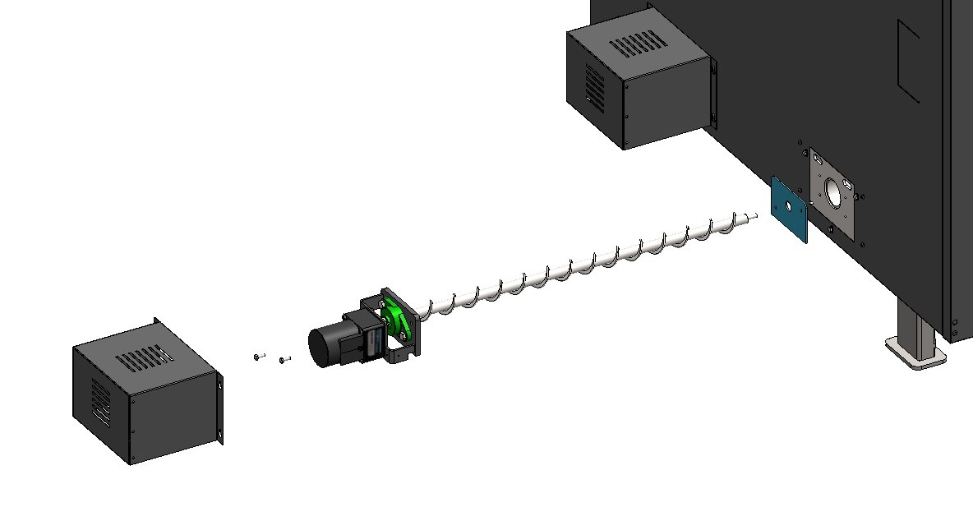
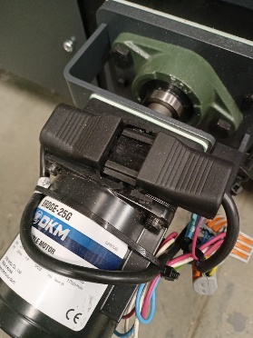
- Fit the motor cover (e) onto the screws (f) - if the cover fits, tighten the screws
a
c
b
f
d
e

The next step is to install the ashtray on the other side of the boiler:
- Screw the flange (g) with the gasket (h) using 4pcs M6 screws (i) so that the flange fits and seals
- Open the ashtray lid (j) with 4 pcs of staples (k) and check that it is empty.
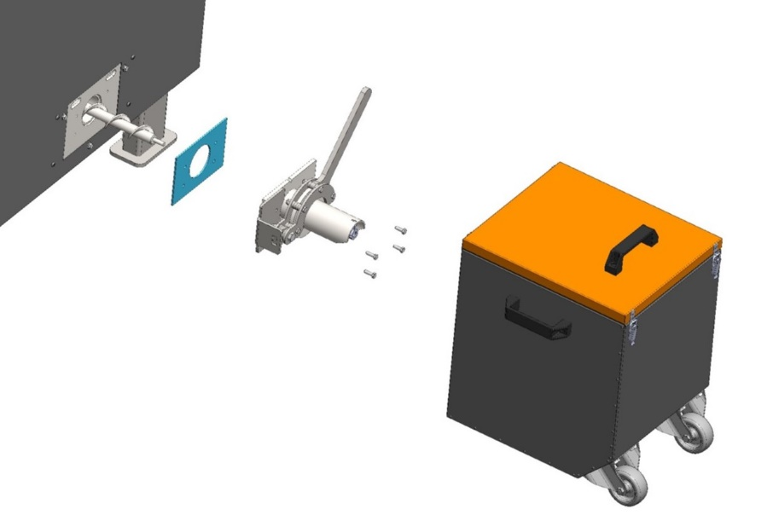
- Slide the ashtray (m) onto the flange and secure it with the lever (n) in the locked position.
h
g
n
j
k
i
m

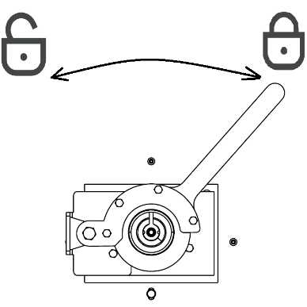

Burner
Before installing the burner, it is first necessary to choose which side the arm mechanism is to open. The type and size of the burner always depends on the size of the Biopel MINI boiler. The burner mounting method therefore varies according to the size of the burner and the boiler. The whole assembly can be summarised in the main points below:
- Prepare all components and unwrap the arm mechanism from the foil.
- Insert the calibration sheet into the burner hole, this serves as a gauge for the initial position of the burner.
- Carefully insert the burner so that the bottom surface of the nose of the burner sits on the calibration sheet, this will define the distance of the burner for subsequent clamping.
- Attach the demarcation washer to the side of the burner skeleton (same side as the arm mechanism) and snap the 2 hinged bolts (installed on the boiler). Use the star clips to tighten the burner. Check that the holes of the demarcation washer fit with the nuts on the burner skeleton. The joint must be tight enough to prevent the burner from moving in the following steps, but we will still loosen it at the end of the process.
- Next, attach the flange of the arm mechanism to the fixed side of the burner using the supplied M8x30 screws (these screws set the vertical movement). Then loosen the M10x25 bolts (these bolts set the burner tilt) so that the bottom surface of the skeleton rests against the calibration sheet. Then tighten all screws securely. Connect the 2x compressor cleaning hoses (h, photo page 20) and plug the electrical connector into the burner. Insert the burner tube into the top hole of the burner and tighten it with the M4 x 8 screws.
- Now it is enough to loosen the two star clips, remove the screws, slide out the burner, remove the calibration sheet and tighten the burner again. The joint must be as tight as possible. Push on the burner several times during tightening to ensure that the burner is firmly attached and that it does not move in any direction. If you have manipulated the external hopper during burner installation, place it back in its final position. Replace the burner cover.
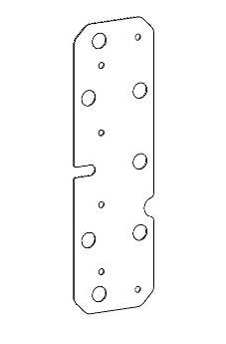
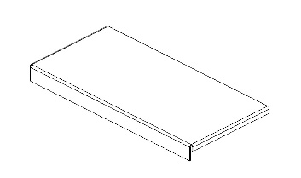
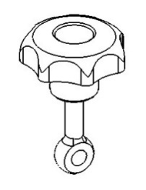
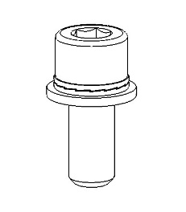
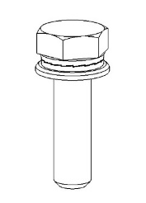
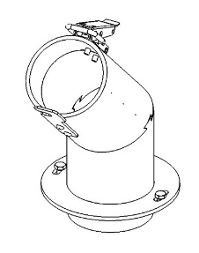
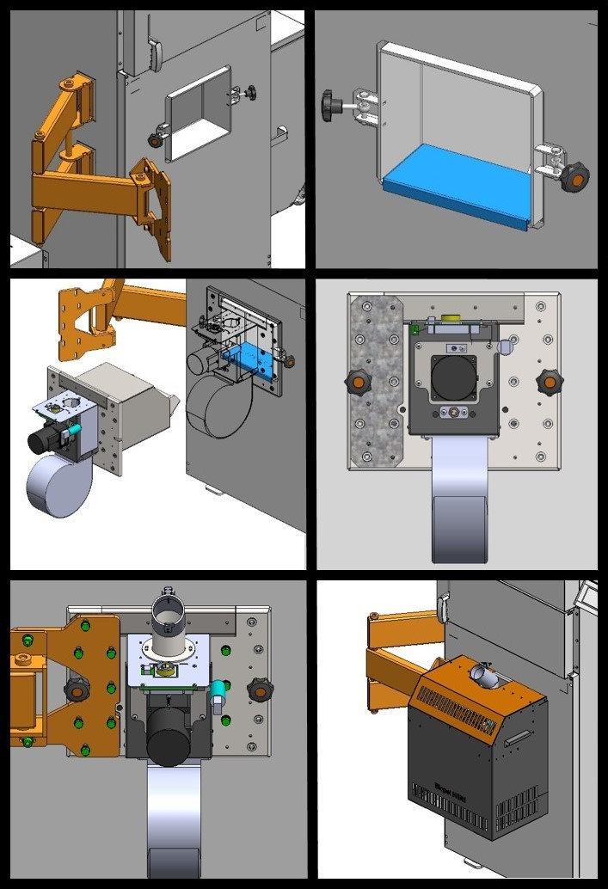
* Skeleton means the welded structure of the burner
The following figures describe the burner assembly procedure. The arm mechanism (orange) is supplied as a fitted part of the boiler.
1 x burner tube
2 x screw M4 x 8
1x calibration sheet

10x M8 x 30
10x M8 Nordlock washer
10x M8 flat washer

2 x star clip
2 x hinged screw
10x M10x30
10x M10 Nordlock washer
10x M10 flat washer
1x demarcation washer
1.
2.

5.
6.
3.
M10
M4
M8
4.
M8
3.
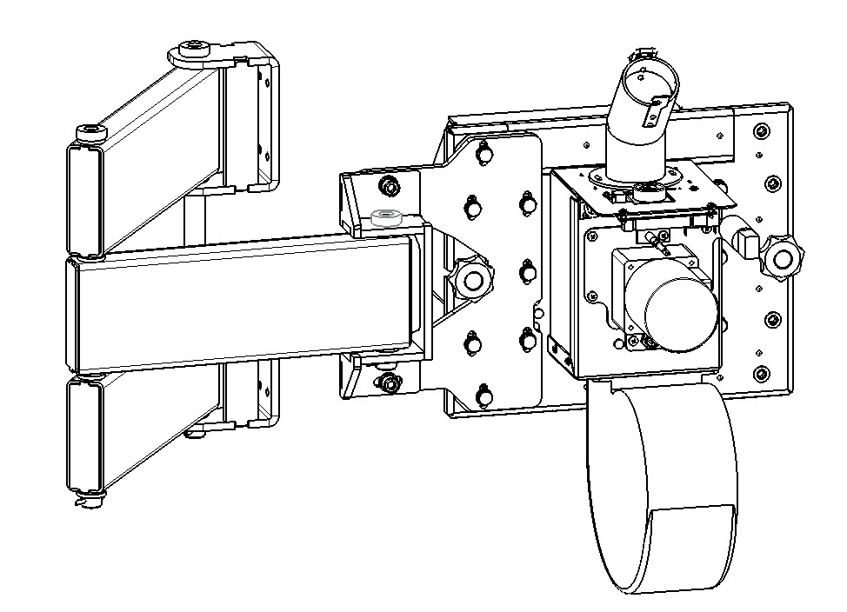
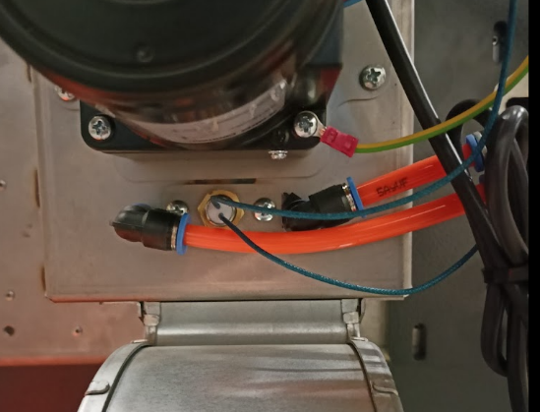
M10 x 25
M10 x 25
M8 x 30
M8 x 30
M8 x 30
M8 x 30
M8 x 30
M4 x 8
h

External Hopper
The external hopper is assembled during boiler installation and is sold as standard in disassembled condition. The end of the external feeder is inserted into the bottom leg of the hopper. The slope of the external feeder should be 45° from the ground. The feeder is connected to the burner by PVC hose and burner pipe. The power supply of the external feeder is routed from the external socket to the socket of the external feeder by means of a 230V cable.
The cabling going to and from the external socket is routed through side shafts at the top of the boiler.
In the hopper you will find the external feeder. Its outlet is at the front of the hopper and must be connected to the burner using PVC hose and a burner tube (burner accessory). The feeder connector must be connected to the external boiler socket with a 230V cable.

Caution: make sure that the PVC hose is not slack, otherwise the pellets falling from the outlet of the external feeder into the burner can get stuck inside the PVC hose.
The external hopper can be placed anywhere in the boiler room, but only in such a way as to ensure a smooth fall of pellets from the feeder outlet into the burner. Make sure that the PVC hose is not slack, otherwise the pellets falling into the burner may become stuck.
The speed of the motor inside the external feeder varies according to the size of the boiler. The label of the external feeder always indicates for which power range of the boiler the external feeder is designed. Only use the type of external feeder that is designed for your boiler size. Otherwise, the external feeder will be too fast or too slow, causing poor pellet feeding to the burner.
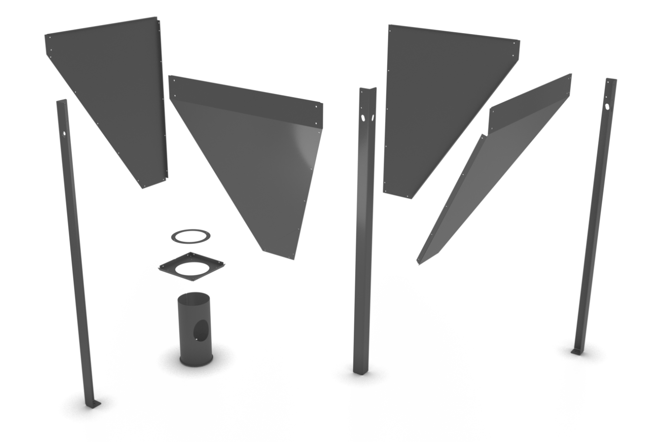

A
B
C
D
E
F
F
F

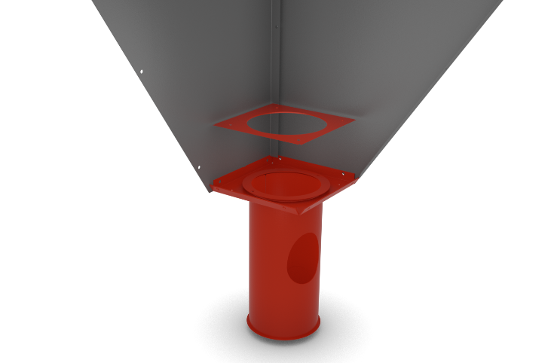

1
2
3
4

A
B
E




C
D

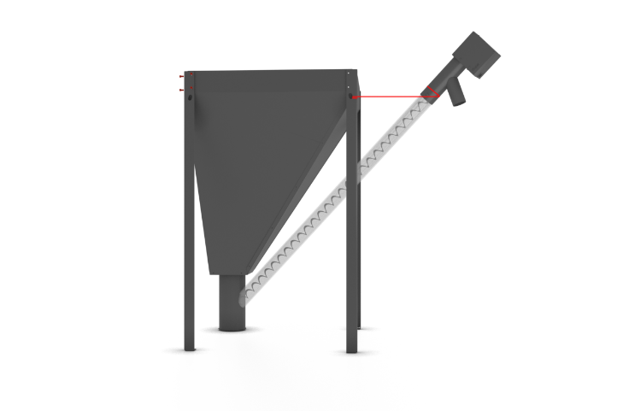
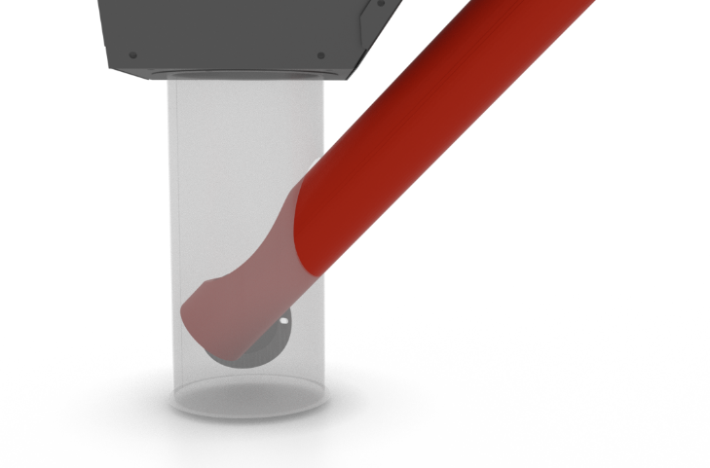
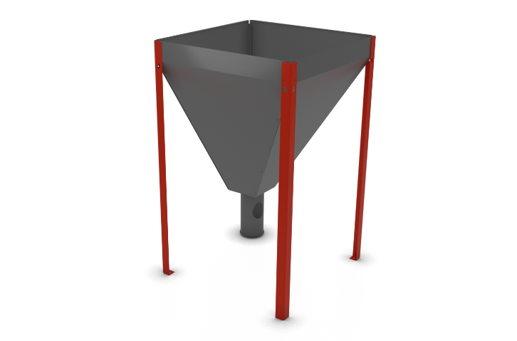
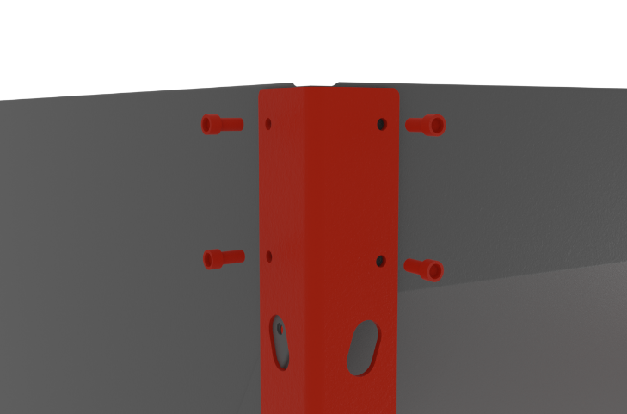
5
6
8
7
F
F

45-55°

The external hopper consists of 4 main plates A, B, C, D, which you connect together one by one. Start by joining the plate A and B, see figure 1.
Then attach the square chimney frame E to the plates A, B. Then put the chimney frame E through and attach with four screws and the last square frame with a round hole, see figure 2.
Continue by joining side plates C and D. Continuously or after the main plates A, B, C, D have been assembled, attach the legs F to the assembly. Attach the legs using 4 screws for each leg separately.
Once the hopper is folded, place it on its legs and move it to the boiler. Then insert the 2 or 3m external feeder into the hopper chimney, see figure 7. The external hopper chimney can be rotated. Therefore, turn it so that the feeder opening faces the burner. After inserting the feeder into the chimney, then re-adjust the position of the hopper and feeder so that the feeder outlet is positioned above the burner.
Attach the feeder to the hopper with a chain and hook so that the angle of the feeder from the ground is between 45-55°. This ensures the expected fuel feeding.
If the boiler room premises do not allow the installation of the feeder at a given angle, it is then absolutely necessary to perform the feeder calibration in the installation settings. After performing the feeder calibration, check the pellet burn and adjust the fan speed in the Coefficients menu in the installation settings so that the flame does not create smoke.
Make sure that the outlet of the feeder is as far as possible above the burner, so that when the burner and feeder are connected by PVC hose, the hose does not become slack to such an extent that the pellets can get stuck in the hose.

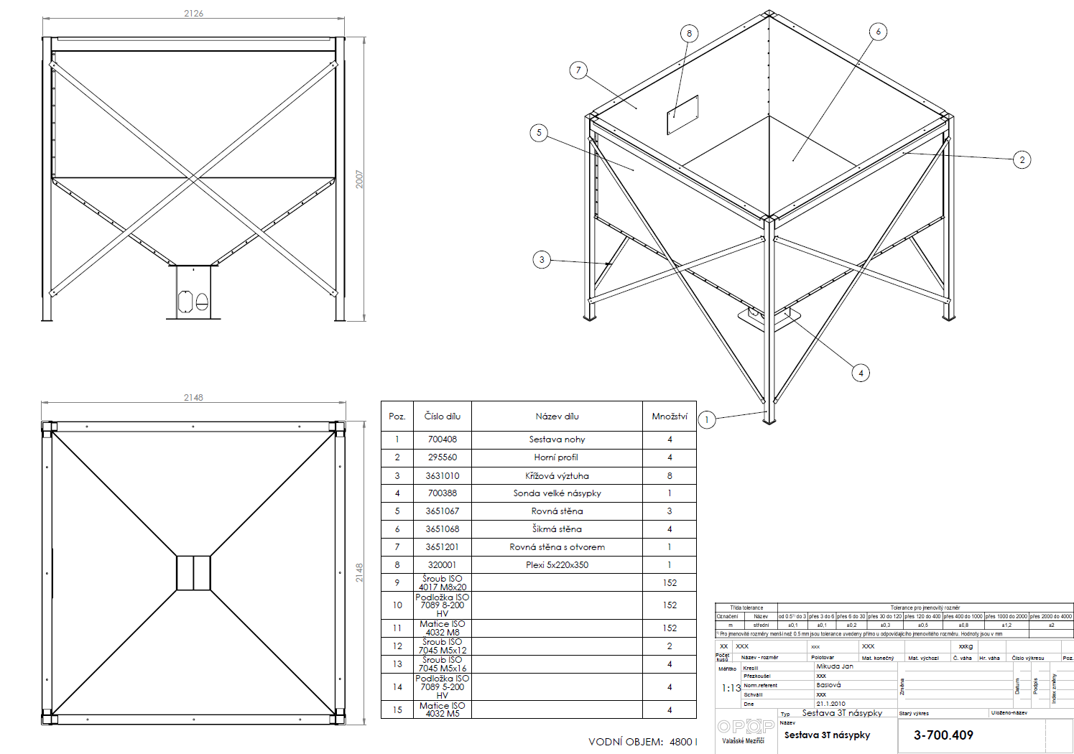
3T hopper assembly
WATER VOLUME: 4800 l

Pos. | Part number | Part name | Quantity
1 | 700408 | Leg assembly | 4
2 | 295560 | Upper profile | 4
3 | 3631010 | Cross brace | 8
4 | 700388 | Large hopper probe | 1
5 | 3651067 | Straight wall | 3
6 | 3651068 | Inclined wall | 4
7 | 3651201 | Straight wall with opening | 1
8 | 320001 | Plexiglas 5x220x350 | 1
9 | Screw ISO 4017 M8x20 |  | 152
10 | Washer ISO 7089 8-200 HV |  | 152
11 | Matice ISO 4032 M8 |  | 152
12 | Screw ISO 7045 M5x12 |  | 2
13 | Screw ISO 7045 M5x16 |  | 4
14 | Washer ISO 7089 5-200 HV |  | 4
15 | Nut ISO 4032 M5 |  | 4

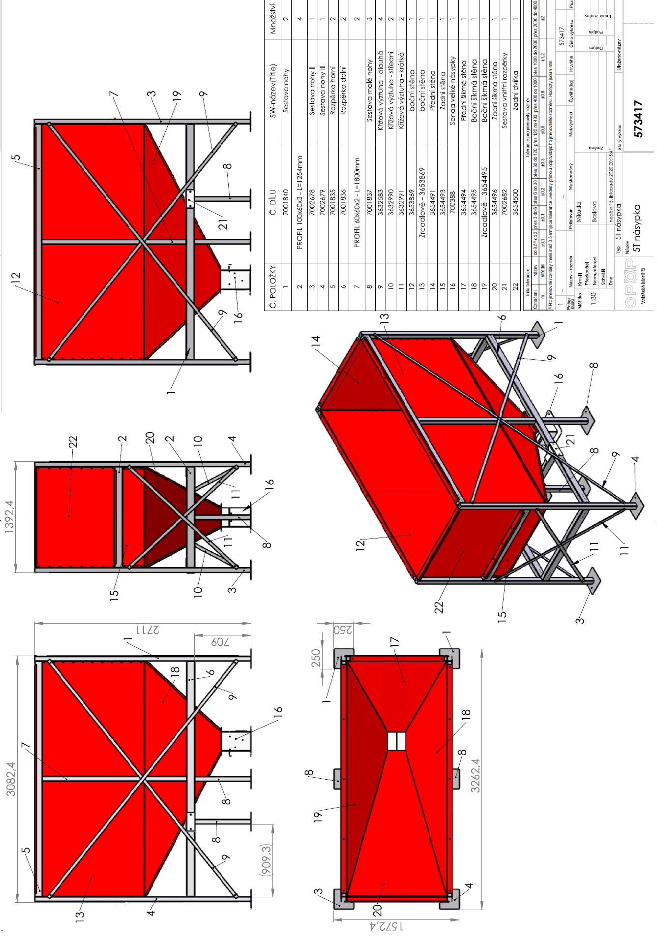
5T hopper
Pos. | Part number | Part name | Quantity
1 | 7001840 | Leg assembly | 2
2 | PROFIL 100x60x3- L=1254mm |  | 4
3 | 7002678 | Leg assembly II | 1
4 | 7002679 | Leg assembly III | 1
S | 7001835 | Upper spacer | 2
6 | 7001836 | Lower spacer | 2
7 | PROFIL 60x60x2 - L=1800mm |  | 2
8 | 7001837 | Small leg assembly | 3
9 | 3632583 | Cross brace - long | 4
10 | 3632990 | Cross brace - medium | 2
11 | 3632991 | Cross brace - short | 2
12 | 3653869 | side wall | 1
13 | Mirrored - 3653869 | side wall | 1
14 | 3654491 | front wall | 1
15 | 3654493 | rear wall | 1
16 | 700388 | Large hopper probe | 1
17 | 3654494 | Front inclined wall | 1
18 | 3654495 | Side inclined wall | 1
19 | Mirrored - 3654495 | Side inclined wall | 1
20 | 3654496 | Rear inclined wall | 1
21 | 7002682 | Internal spacer assembly | 1
22 | 3654500 | Rear door | 1

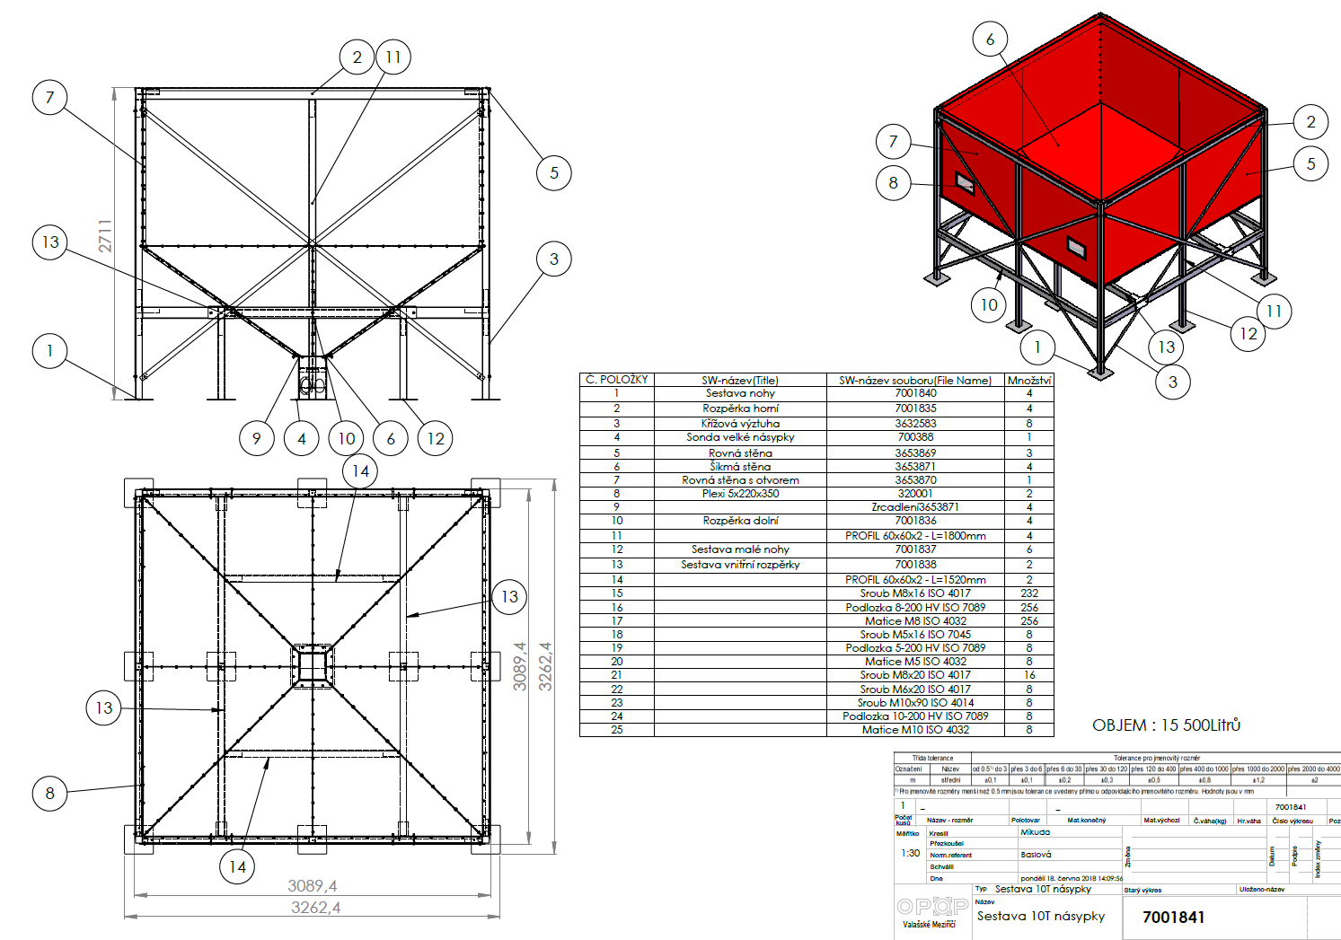
10T hopper assembly
Pos. | Part name | File name | Quantity
1 | Leg assembly | 7001840 | 4
2 | Upper spacer | 7001835 | 4
3 | Cross brace | 3632583 | 8
4 | Large hopper probe | 700388 | 1
5 | Straight wall | 3653869 | 3
6 | Inclined waall | 3653871 | 4
7 | Straight wall with opening | 3653870 | 1
8 | Plexiglas 5x220x350 | 320001 | 2
9 |  | Mirroring 3653871 | 4
10 | Bottom spacer | 7001836 | 4
11 |  | PROFIL 60x60x2 - L= 1800mm | 4
12 | Small leg assembly | 7001837 | 6
13 | Inner spacer assembly | 7001838 | 2
14 |  | PROFIL 60x60x2-L=1520mm | 2
15 |  | Screw M8x16 ISO 4017 | 232
16 |  | Washer 8-200 HV ISO 7089 | 256
17 |  | Nut M8 ISO 4032 | 256
18 |  | Screw M5x16 ISO 7045 | 8
19 |  | Washer 5-200 HV ISO 7089 | 8
20 |  | Nut M5 ISO 4032 | 8
21 |  | Screw M8x20 ISO 4017 | 16
22 |  | Screw M6x20 ISO 4017 | 8
23 |  | Screw M10x90 ISO 4014 | 8
24 |  | Washer 10-200 HV ISO 7089 | 8
25 |  | Nut M10 ISO 4032 | 8

External feeder
The installation of the external feeder is carried out in combination with the external pellet hopper. Remove the paper wrapping from the top of the external feeder.
- Make sure that no parts of the feeder are damaged during handling. Check the bottom part of the feeder where the worm shaft comes out of the PVC tube. The hole at the end of the PVC tube must not be deformed in any way. The edges of the tube opening must be horizontal with the tube body, not curved inwards (towards the worm shaft). If this were the case, there would be a risk of the worm shaft catching on the PVC tube bore and possibly jamming the feeder.
- Rotate the lower leg of the external hopper so that the hole in it faces the boiler.
- Slide the bottom end of the external feeder into the hole in the hopper leg. The hole in the bottom part of the external feeder must be all the way inside the bottom leg of the external hopper.
- Using the chain and hook (included with the external hopper), hook the top of the external hopper behind the top edge of the external hopper or behind the holes in the top of the external hopper legs.
- Adjust the chain so that the external feeder is at an angle of approx. 45° from the ground. If the angle is smaller, the feeder will dispense more pellets than the standard, if the angle is larger, the feeder will dispense fewer pellets than the standard. If the angle is not standard, a combustion correction will be necessary, see chapter Combustion correction.
The feeder must be at a 45° angle to the ground for correct fuel dosing, if this is not the case, make an adequate combustion correction, see chapter Combustion Correction.
The external feeder is placed, followed by its connection to the burner. Follow the steps indicated below:
- Place the burner tube into the hole in the top of the burner, remembering the sealing ring.
- Secure the burner tube with 3pcs black screws.
- Connect the outlet of the external feeder and the burner tube with PVC hose. Caution: the PVC hose must not be slack to the extent that the pellets will get stuck in it. The pellets must drop inside the PVC hose without jamming into the burner. Check the correct installation of the PVC hose during boiler operation!

Compressor cleaning
Compressor cleaning of the boiler burner and heat exchanger, which substantially prolongs the need for manual maintenance of the boiler and burner. The compressor cleaning connection is situated at the rear of the boiler.

Compressor cleaning includes:
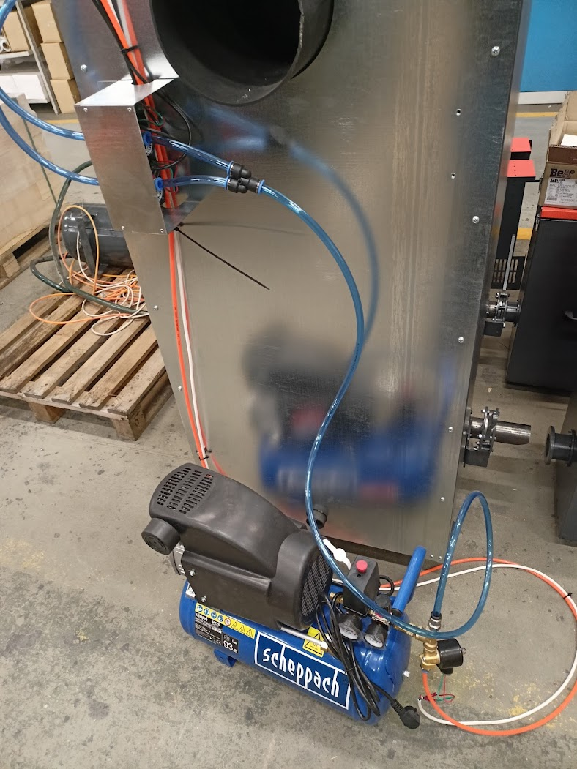
- Compressor
- Air cleaner
- Control valve

Control unit
The external feeder is connected to the burner, all that remains is the electrical connection of the main cables and the connection of the v9 MINI control unit. Follow the steps below:
- Connect the 230V power cable to the socket that will electrically supply the boiler.
- Connect the 230V cable from the control unit to the socket at the top of the external feeder.
- Connect the burner cable with the two connectors to the sockets at the top of the burner. See photo below
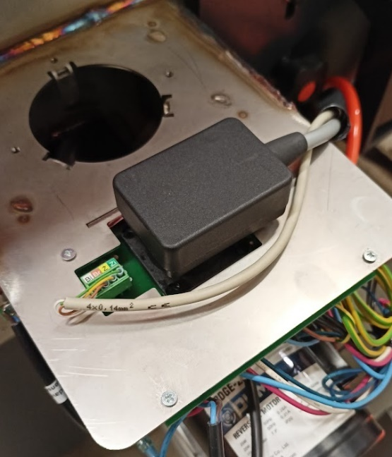

The basic electrical wiring is complete. If you are connecting additional devices to the control unit, use the cable shafts on the top of the boiler.
The boiler must never be operated with unsecured or leaking ash containers. In addition, the front inspection door must be secured. Otherwise there is a risk of damage to the boiler's electrical components due to hot air leakage.
A diagram of the electrical outputs in the control unit is shown on the next page. Use this diagram to connect other auxiliary devices of your choice. Once all electrical components are connected, place the top cover back on the boiler and you can start the boiler for the first time using the main switch (red button on top of the boiler).
The installation is practically complete at this point. This is followed by the so-called first boiler start-up and combustion correction, described in the chapters First boiler start-up and Combustion correction. Before proceeding to these steps, we recommend that you study the basic boiler control and the description of the menu items in the chapters Boiler control unit and Description of control unit functions.
Before starting the boiler for the first time, read the chapters Electrical connection of accessories, Control unit and Description of control unit functions.
These chapters will help you understand how to operate the boiler and the v9 MINI boiler unit. Use these chapters also for the installation of accessories, which you will then activate during the first start-up of the boiler and, if necessary, set up in the Installation menu. Keep in mind that the operation of the accessories is preset in the factory settings, so you only need to activate them and they should operate under standard conditions without any problems. The settings for the operation of the additional devices can be changed at any time in the Installation Menu.

Electrical connection of accessories

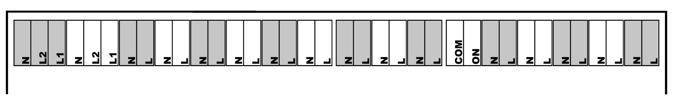
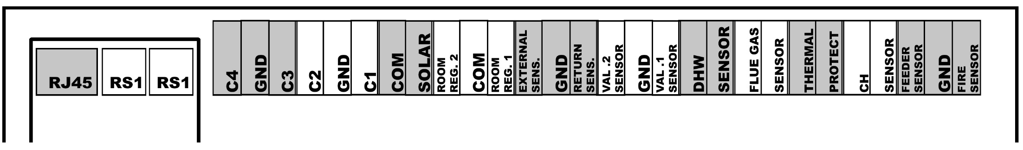
Joint output for Feeder and Fire sens.
Internal feeder temperature sensor
Joint output outdoor and return sensor
Mixing valve 1
Valve 1
Valve 2
Mixing valve 2
Valve 1 pump
Aditional pump
Additional pump
Valve 2 pump
Valve 2 pump
Valve 1 pump
Feeder 2
Internal burner feeder
DHW (TUV) pump
DHW (TUV) pump
CH pump
CH (ÚT) pump
Fan
Fan
External pellet feeder
Feeder 1
Heater
Heater
Deashing
Comp.3
Ash remover
Compressor 3
Freely programmable output
Voltage free output
Compressor 2
Comp.2
Compressor 1
Comp.1
Vacuum feeder
Vacuum
Flue gas temperature sensor
Outdoor sensor
Room thermostat 1
Joint output Room reg.1,2
Joint output for Val.2, Val.1
Valve sensor 2
Photosensor (flame sensor)
TUV sensor
CT /ÚT/ sensor
Safety sensor Termik
Valve sensor 1
Return water sensosr
Solar contact
Room thermostat 2
Additional sensor 1
Joint output for C2, C1
Additional sensor 2
Additional sensor 3
Joint output for C4,C3
Additional sensor 4
Internet connection with RJ45 cable
RS bus outputs for accessories connection
There follows a listing of the control unit functions associated with the individual outputs in the external socket. Use this listing to better navigate through the setup and activation of additional devices. Similarly, this list can be used to easily locate the source of an alarm message if a function has been activated but the associated sensor is not connected.
- RJR5 – Installation menu:
    - Ethernet module.
- RS1 and 2 – Installation menu:
    - Lambda
    - Room thermostat
    - Additional valve 1 and 2
    - GSM module
    - Cascade controller.
- Additional sensor 4 and 3 – Installation menu:
    - Future use
- Additional sensor 2 and 1 - Installation menu:
    - Additional pump
    - Buffer tank parameters
    - Built-in valve 1,2 – Selection of CH (ÚT) sensor
- Solar contact – Installation menu:
    - Solar control.
- Room thermostat 1 and 2 – Installation menu:
    - Room thermostat - Standard regulator 1 and 2
    - Built-in valve 1,2 – Room thermostat – Thermostat standard.
- Outdoor sensor – Installation menu:
    - Built.in valve 1 and 2 – Equitherm control
    - Outdoor temperature correction
    - Firing up blocked
- Return water sensor – Installation menu:
    - Built-in valve 1 and 2 – Return flow protection
- Valve sensor 2 and 1 – Installation menu:
    - Built-in valve 1 and 2
- DHW (TUV) sensor – Main settings:
    - Operating mode – DHW (TUV) priority or Parallel pumps or Summer mode
– Service menu:
    - Disinfection – Disinfection temperature
    - Priority temperature
    - DHW (TUV) hysteresis
- Flue gas temperature sensor – Service menu:
    - Max. flue gas temperature
- Safety sensor Termik – no associated function
- CH (ÚT) sensor – Main settings:
    - CH (ÚT) temperature setpoint
    - Boiler weekly programme
    - Operating modes – House heating
– Installation menu:
- Built-in valve 1,2 – Boiler protection
– Service menu:
- CH (ÚT) pump emergency activation
- Boiler alarm temperature
- Pump switch-on temperature
- Min. boiler temperature
- Boiler hysteresis
- Internal feeder temperature sensor – Service menu:
    - Feeder alarm temperature
- Photosensor – Service menu:
    - Pellet settings – Ignition parameters – Firing-up brightness
    - Pellet settings – Operating parameters – Operation control

- Mixing valve 2 and 1 – Installation menu:
    - Built-in valve 1,2
- Additional pump – Installation menu:
    - Additional pump
– Service menu:
- Pump switch-on temperature
- Valve pump 2 and 1 – Installation menu:
    - Built-in valve 1,2 – Valve pump 1,2
- DHW (TUV) pump – Main settings:
    - Operating mode – DHW (TUV) priority or Parallel pumps or Summer mode
– Service menu:
- Pump switch-on temperature
- DHW (TUV) hysteresis
- CH (ÚT) pump – Main settings:
    - Operating mode – House heating or DHW (TUV) priority or Parallel pumps
– Service menu:
- Pump switch-on temperature
- Internal burner feeder – Service menu:
    - Internal feeder coefficient
    - Pellet settings – Ignition parameters – Feed time and feed pauses
    - Pellet settings – Damping parameters – Feed time and feed pauses
- External pellet feeder – Service menu:
    - Pellet settings - Ignition parameters – Feed time
    - Pellet settings – Operating parameters – Minimum power – Maximum feeder pause and Minimum feeder operation
    - Pellet settings - Operating parameters – Maximum power – Minimum feeder pause and Maximum feeder operation
– Installation menu:
    - Coefficients – Min feeder coefficient a Max feeder coefficient
- Fan – Main settings:
    - Burner cleaning
– Service menu:
    - Pellet settings – Ignition parameters – Blow out time, Blow out speed, Fan speed 1,2, Fan delay
    - Pellet settings - Operating parameters – Minimum power – Min. fan speed operation
    - Pellet settings - Operating parameters – Maximum power – Max. fan speed operation
    - Pellet settings - Operating parameters – Cleaning period
    - Pellet settings – Damping parameters – Fan speed
– Installation menu:
    - Coefficients – Fan lower correction and Fan upper correction
- Igniter – Service menu:
    - Pellet settings – Ignition parameters – Heater protection and Min. heater power
- Freely programmable output – no associated function
- Ash removal – (Installation menu) – De-ashing device
- Vacuum feeder – (Installation menu) – Vacuum feeder
- Compressor 3 and 2 and 1 – (Installation menu) – Compressor 1 and 2 and 3

BOILER CONTROL UNIT
The v9 MINI boiler control unit is equipped with a high-resolution touch screen. The display is set to high touch sensitivity to ensure easy operation in boiler room conditions. Furthermore, it is protected by plexiglass, which shields the display itself against damage. The display is connected by a data cable to a connector on the top of the boiler, where the control unit is located. After the boiler is activated, i.e. the boiler is switched on using the main switch on the top of the boiler, the display is activated and the current software version is checked in the display and control unit. The software version numbers are displayed on the unit display together with the OPOP spol. s.r.o. logo when the unit is started. These numbers must be identical for correct operation of the boiler. If they are not, the unit will remain idle in the synchronization part and it is necessary to update the software via the USB connector on the display.
This is followed by the language selection, which is displayed when the unit is first activated. You can also change the language at any time in the unit's menu using the “Language selection” button with a picture of flags. After selecting the language, we recommend that you read the following sections to familiarize yourself with the functions of the v9 MINI control unit.

Basic navigation
The basic operation is intuitive thanks to the touch screen, which simplifies the whole control. Read below the basic description of the main panel of the boiler control unit, i.e. what you can read and control from it.
r
n
o
m
l
k
j
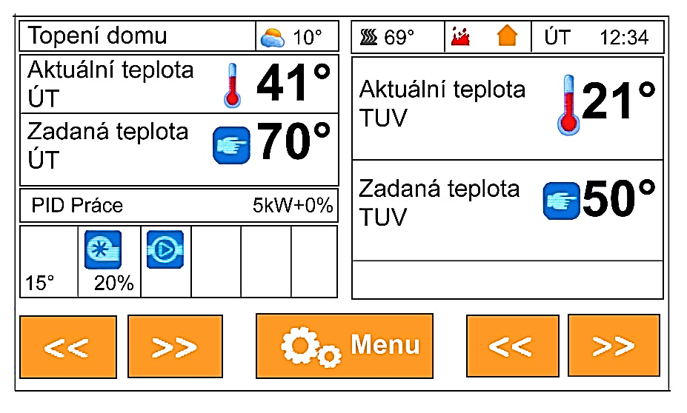
!
q
p
i
h
g
f
e
d
c
b
a
v9 MINI control unit main panel
- CH temperature measured by the CH sensor connected to the pit on the outlet sleeve at the back of the boiler.
- The selected CH (ÚT) temperature set in the Main Menu of the unit. Standard 65-80°C.
- Current operating mode of the boiler - Ignition, PID operation or extinction.
- Current power in kW.
- Combustion correction made using the functions under Coefficients in the Installation Menu.
- Temperature of the internal feeder in the burner, normally in the range 15-55°C.
- Panel showing the operation of electrical components such as fan, feeders, pumps and auxiliary devices.
- DHW temperature measured by the DHW sensor and connected to the “DHW sens.” output in the external boiler socket.
- The DHW setpoint temperature set in the Main Menu of the unit. It works if the DHW pump is activated in the Main settings,
- Operating modes. Displaying the operating mode of the pumps, according to the Operating Modes setting in the Main settings.
- Outdoor temperature, measured by an outdoor sensor connected to the “Weather sens.” output. In the external boiler socket.
- Flue gas temperature, measured by the Flue Gas Temperature Sensor. Standard range 70-110°C, depending on boiler output.
- Flame detection by photosensor. If the icon is displayed, the photosensor detects a flame in the boiler.
- Display of room thermostat operation if activated in the Installation menu, Room Thermostat.
- The current date and time entered in the Main settings.
- Menu button, to enter the boiler unit menu.
- Change the display of the main panel, displaying various information about the operation of the boiler and its auxiliary devices.
- Detection of operating errors - use the right/left arrows to navigate the DPCH panel, which informs the customer about non-standard boiler operation conditions. When the panel is pressed, an activity history will be displayed where you can learn how to solve specific problems.

Basic operating modes
The Biopel goes through several operating modes during its operation, which are displayed on the Main Panel. Below you will find an explanation of what these operating modes mean and what messages are associated with them.
Ignitions: automatic ignition of pellets on the grate. Maximum time set to 12min, during this time the boiler goes through several operating stages:
- Pre-ventilation - cleaning the grate with a fan, factory setting (hereafter referred to as TN) = 30s.
- Sub-base time - pellet dosing by the feeder, the internal feeder in the burner works once long enough to push all the pellets onto the burner grate. TN = 12 – 15s
- Fan delay - preheating the ignition cartridge (igniter) before starting the fan. TN = 30s
- Fan speed 1 - fan speed during the first 6 min of ignition. The fan operates at low speed to produce a flame without cooling the ignition cartridge. TN: 3-8%.
- Fan speed 2 _ fan speed during the second 6 min of ignition. Maximum ignition cycle is 12min. If the pellets are not ignited during the first 6min, the fan will increase its speed to create a flame. The standard ignition time is 3-6min. TN: 5-16%.
- Delayed ignition - the flame has been created, the photosensor detects the light, followed by flame stabilization. If the flame detection by the photosensor is stable, the boiler goes into PID operation (normal operation), if the flame detection by the photosensor is not stable, the boiler remains in the Ignition phase until the flame is large enough. If the flame is extinct, a second Ignition follows (maximum another 12 min).
- The output of the Ignition phase can be:
  - Transition to PID work - normal boiler operation, or
  - Alarm message - Ignition error, pellets failed to ignite for some reason. The boiler tries Ignition twice before this error condition is announced. For more information, please refer to the chapter Operation and Error Messages.
PID mode: normal boiler operation, indicated by the current boiler power and fan speed in %, which is the same as the percentage of the current output. In PID operation, the following operating states take place:
- Min power - the boiler starts its operation in the lower half of the power spectrum, i.e. 0-50% of the maximum power. The reason for this is to ensure that the small flame is not smothered by large quantities of pellets after ignition. TN = 1-50% of maximum output, depending on the boiler type.
- Max. power - the boiler gradually increases its power up to the maximum, i.e. 100%. This can take 5 to 15 minutes, depending on the boiler type. The modulation is then influenced by the set and measured CH temperature.
- PID modulation - After approaching the set CH temperature, the boiler starts to modulate the output to keep the set temperature within the limit given by the factory setting in the Service menu. The set boiler temperature can be exceeded by 5°C. This is also the modulation range within which the boiler attempts to maintain the CH temperature so that it does not have to enter the Extinction stage if the specified temperature is exceeded by 5°C or more.
- The output of the ignition stage can be:
  - Transition to Extinction - the set CH temperature exceeded by 5°C
  - Continuous PID operation - the set CH temperature is not exceeded by 5°C due to downward power modulation. The boiler remains in PID operation and maintains the CH temperature at the setpoint due to up and down power modulation.
  - Shutdown by thermostat - the room thermostat forces the transition from PID operation to Extinction as the room temperature has been reached.
Extinction: the stage that the boiler enters when heated up to the set temperature of CT + 5°C, thanks to the room thermostat that does not instruct the heating. The following operating states take place during the extinction stage:
- Cleaning - the first phase of extinction. The photosensor still detects a flame in the boiler, so the boiler tries to burn it out by deactivating the external feeder and increasing the fan speed to 70%. This continues for a set time or until the boiler is no longer flaming.
- Cooling - after all the remaining pellets on the grate have burned out, the photosensor no longer detects the light, so the boiler goes into the second stage of extinction, which is cooling. The fan speed is 100%. The grate is cooled by the fan to prevent deformation. The grate can only deform without fresh air supply, so the fan cools it. TN (factory setting) = 5-15min depending on boiler type.
After the Extinction is complete, the unit reports “Stand by” message. This is a standby mode where the boiler waits for conditions to reactivate the Ignition stage. This situation occurs if the measured CH temperature drops by 15°C or if the room thermostat instructs the heating.

DESCRIPTION OF CONTROL UNIT FUNCTIONS
In this chapter you will find a complete description of all functions in the menu of the v9 MINI control unit. This list serves as a basic introduction to the individual functions. For all functions, you will find recommended settings and a description of what each item controls and information on how the functions are interrelated.

First start-up
The first start-up of the boiler is used by the installer to simply set the basic operating parameters for proper boiler operation. Therefore, this menu is secured with an access code and only a certified installation company has access to this menu. There is a whole chapter in the manual dedicated to this menu.

Ignition / Extinction
This function is used to activate and deactivate the boiler. If the boiler is deactivated, then you will see the indication "Ignition". After pressing it and confirming it, the boiler will enter the automatic pellet ignition mode. After about 5 minutes, the ignition will occur and switch to the so-called PID operation. If the boiler is activated, i.e. in PID work or Ignition, then you will see the Extinction indication here. After pressing it and confirming it, the boiler will enter the Extinction mode. The feeders will stop feeding fuel and the fan will increase fan speed to clean and cool the grate. This takes 5-15min depending on the size of the burner. The boiler then shuts down and remains deactivated until the ignition button is pressed.

Main settings
This setting contains user functions that modify the operation of the boiler but do not affect the operation of the boiler and auxiliary devices important for their proper function.
1. Set CH (ÚT) temperature | Select the central heating temperature (maximum boiler temperature). We recommend setting it between 60-80°C. Higher temperature is better for proper boiler operation and long boiler life. | 60–80°C
2. Set DHW (TUV) temperature | Select the desired service water temperature. DHW is only activated if the DHW sensor is connected to the “DHW sensor” output in the external socket and if the operating mode in the Main Settings is correctly selected. | 45–70°C

3. Burner cleaning | Activation of the fan for cleaning the burner grate. The fan periodically increases its speed to clean the burner grate.
3.1 Cleaning period | Time between cleaning. Larger burner / more frequent cleaning required. | 6-15min
3.2 Fan operation time | Cleaning time. Larger burner / longer cleaning time required. | 10-20s
3.3 Blowing intensity | Fan speed during cleaning. Larger burner / faster speed required. Beware of high speed during cleaning. High speed (especially during low boiler output) can cause extinction (no flame after cleaning). High speed can also cause unburned pellets to fall into the ash tray. Reduce the fan speed if any of the following situations occur. | 50-100%.

4. Operating modes | Operating mode of CH and DHW pumps connected to external socket. Select the time that the pumps are to be switched on and off. Caution: the CH and DHW pumps only operate in this mode if the current CH temperature is above 40°C. This is set in the Service menu, Pump switch-on temperature. The activated pump is indicated on the Main Panel with a mark
4.1 House heating *¹ | Only the central heating pump is working. The pump switch-on temperature is set to 40°C. DHW pump is deactivated.
4.2 DHW (TUV) priority *² | The DHW pump is superior to the CH pump. The moment the DHW temperature is reached - the DHW pump is deactivated and the CH pump is switched on for heating the house. The moment the DHW temperature falls below the TV Hysteresis - the CH pump is deactivated and the DHW pump is restarted until the DHW temperature reaches the desired value.
4.3 Parallel pumps *² | Both DHW and CH pumps work simultaneously to heat both the house and the boiler.
4.4 Summer mode *² | Only the DHW pump is activated for boiler heating.
*¹ Connecting the CH pump to the “CH pump” output in the control unit.
*² Connecting the DHW pump to the “DHW pump” output in the control unit.
5. Container filled | You specify that the pellet hopper has been filled. If hopper calibration has been performed in the Installation Menu, 100% pellet level will be displayed on the unit's main panel.  To display the fuel quantity indicator correctly, you must first calibrate the fuel consumption in the hopper calibration function in the Installation Menu.

6. Boiler´s weekly programme | Allows weekly adjustment of the CH temperature during every hour, every day of the week. BY + - 20°C. If one of the modes is activated, the current temperature lowering is then displayed on the Main Panel under the Set CH Temperature.
6.1 Mode 1 (Mon-Sun) | Activates Mode 1.
6.2 Mode 2 (Mon-Fri) (Sat-Sun) | Activates Mode 2.
6.3 Mode 1 settings | Select the desired CH temperature adjustments for Mode 1.
6.4 Mode 2 settings | Select the desired CH temperature adjustments for Mode 2.

7. Alarm history | Displaying the alarm and operating message history.

8. Disinfection | Temperature disinfection works in conjunction with DHW heating and can only be activated if the DHW pump is activated in Main Settings, Operating Modes. Temperature disinfection raises the set DHW temperature to the minimum value required for successful disinfection (min. 60°C) throughout the DHW circuit.

9.1 Display settings | Change any settings related to the v9 MINI's main display settings, such as display brightness, display saving, etc.
9.2 Main panels | Display of different types of main panels (display of main data on the screen).
9.2.1 Panel view | End-user display.
9.2.1.1 Manufacturer´s screen | Display for the person performing the installation.
9.2.1.2 Display brightness | Change the display brightness for better visibility of the displays.
9.3 Display saving mode | Select brightness in power saving display mode to save power consumption.
9.4 Extinction time | Select how long it takes for the display to enter power saving mode if the user does not use it for this period of time.
9.5 Alarm sound | Activates/deactivates the sound during an alarm situation.
9.6 Button sound | Activates/deactivates the sound when the touchscreen is pressed.
9.7 Programme update | Forcibly updates the program in the v9 MINI control unit. The standard way of updating the programme in the control unit and the external socket is described in the chapter Firmware update.

10. Factory settings (TN) | Reset the user-changed Main Settings values to the factory defaults.

11. Programme information | Current version of the programme. Caution: there are two types of programme (firmware) - for the v9 MINI display and for the control unit. For more information on uploading a new programme, please refer to the chapter Updating the firmware.

The items in the Main Menu do not have a significant effect on the operation of the boiler. Even so, if you are unsure about the setting of any of the functions, we recommend that you consult a certified installation technician or a representative of OPOP s.r.o. We will be happy to assist you in explaining all items not only in the Main Menu but also in other settings in the control unit.
There follows the Installation Menu, which is intended for the installation technician to set up the combustion process and activate the auxiliary devices. This menu is not secured by a code, so it can be modified by the boiler owner, but it is recommended to consult a certified installation technician or a manufacturer's representative for any changes.

Installation menu
In the installation menu, both the installation technician and the user can activate and adjust the operation of additional devices and also correct the combustion process.
1. Coefficients | Items to correct the flame with the fan and pellet feeder for minimum and maximum boiler output.  All corrections are factory set to 0. The user can decrease this number (-); (lower fan speed or lower pellet feed) or increase this number (+) ; (higher fan speed or higher pellet feed).  The adjusted coefficients are displayed on the main panel at the power indicator (feeder coefficient) and at the fan speed indicator (fan coefficient).
1.1 Max. fan coefficent | This function is responsible for changing the fan speed during normal boiler operation. Only the maximum speed value is changed.
1.2 Min. fan coefficient | This function is responsible for changing the fan speed during normal boiler operation. Only the minimum speed value is changed.
1.3 Min. feeder coefficient | This function adjusts the pellet dosage or the running time of the feeders, which is stored in the service menu. You change the feeder operating times and feeder breaks for the minimum boiler power.
1.4 Max. feeder coefficient | This function adjusts the pellet dosing or feeder run time that is stored in the service menu. Change the feeder operating times and feeder breaks for maximum boiler power.

2. Feeder calibration*¹ | It allows to measure the power of the external feeder for automatic calculation of pellet dosage in relation to the boiler power.  The unit thus automatically ensures that the required amount of pellets is poured into the burner, corresponding to the actual boiler power, which is displayed on the main panel of the unit.  This ensures easier boiler set-up. The installation technician then only adjusts the fan speed for ideal combustion, not the amount of fuel, which is adjusted automatically.
2.1 Fuel calorific value | It is given in MJ/kg of pellets. It has a significant effect on the amount of pellets burned. Please refer to the pellet packaging or ask the pellet manufacturer for this information.
2.2 Container content | Specify the size of the pellet hopper. The main panel then shows how much fuel is left in the hopper.
2.3 Fuel weight | Enter the amount of pellets in grams, weighed using the “Start Weighing” function. From this value, the pellet dosage is calculated automatically by the boiler control unit. The boiler will thus have adequate power according to the requirement of the heating circuits.
2.4 Start weighing | Activation of the external feeder for 5 min. Before activating the function, consider the bag for the external feeder output so that the pellets can fall into the bag. Then activate this function. The feeder will deactivate itself after 5min. Then weigh the contents of the bag on a bench scale and enter the number in grams into the “Fuel weight” function and you have finished.
*¹ In case you activate the Feeder Calibration, you can adjust the Max Boiler Power in the Main Menu. Please note that this option is only active when Feeder Calibration is activated and properly set.
3. Manual operation | Here it is possible to forcibly start all electrical components connected to the boiler, including all auxiliary devices.

4. Room thermostat | Activate the selected room thermostat type. Select the Standard Thermostat, which operates on an open/closed circuit basis, or the RT10 OPOP room thermostat. The fact that the room thermostat has been activated is indicated by the icons.  An orange icon means that the thermostat is instructing the boiler to heat. A red icon means that the thermostat is not instructing the boiler to heat.
4.1 Thermostat standard 1 *¹ | Voltage-free thermostat operating on a closed/open circuit basis. Open circuit means instructing the boiler to enter the Extinction phase, i.e. instructing the boiler to stop heating. Closed circuit means instructing the boiler to go into the Ignition and PID operation phase, i.e. instructing the boiler to heat. The house icon on the Main Panel flashes if the circuit has been closed and the thermostat therefore instructs the heating.
4.2 Thermostat standard 2 *¹ | Voltage-free thermostat operating on a closed/open circuit basis. Open circuit means instructing the boiler to enter the Extinction phase, i.e. instructing the boiler to stop heating. Closed circuit means instructing the boiler to go into the Ignition and PID operation phase, i.e. instructing the boiler to heat. The house icon on the Main Panel flashes if the circuit has been closed and the thermostat therefore instructs the heating.
4.3 OPOP regulator *² | RT10 room thermostat, connected to RS output inside external socket in the front of the boiler.
4.4 Ignition function | If this function is activated, the boiler responds to the instruction from the room thermostat by switching off/on immediately.  If this function is deactivated, the boiler responds to the no heat instruction from the room thermostat by lowering the Setpoint CH temperature by the value set in the Reduce Temperature by thermostat function. This solution is advantageous for heating systems with large volumes of water in the system, where complete deactivation of the boiler would mean a large drop in temperature in the system and a long reheating.
4.5 CH pump – room thermostat | The central heating pump is started and deactivated together with the boiler on the basis of an instruction from the room thermostat. If the boiler switches off, the CH pump is switched off and vice versa.
4.6 Temperature lowering by thermostat | The boiler responds to a shutdown instruction from the room thermostat by lowering the CH temperature by a set limit. In case the item Ignition function is deactivated, then in this item you set by how many °C the set CH temperature is to be lowered so that the boiler operates at a lower temperature and thus saves fuel by automatically modulating the power downwards.
*¹ Connect the thermostat standard 1, 2 to the output "Room reg 1,2 and Com" in the control unit.
*² Connect the OPOP regulator (type RT10) to one of the RS data outputs in the control unit.

5. Lambda * | Regulation of residual oxygen in the boiler using a lambda probe.
5.1 First time for update | Delay of the first regulatory intervention. During this time the lambda sensor is waiting for preheating. After automatic ignition, it is necessary to wait about 5 min before the flame stabilises, then the lambda probe starts to adjust the combustion process. | 5min.
5.2 Update time | Correction period, how often the regulation intervention and O₂ adjustment occurs in the boiler. The recommended time is 3-5min. The larger the burner, the longer the time must be. | 3-5min.
5.3 Oxygen surge | Correction factor for pellet dosing in %. How much is 1 regulation intervention to pellet feed. The regulation will be done according to the set time in the Update Time function. | 2%
5.4 Fan surge | Correction factor for fan speed in %. How big is 1 regulation intervention for fan speed. The regulation will take place according to the time set in the Update Time function. | 2%
5.5 Sum | Should the correction factor (oxygen surge, fan surge) be added at each Update Time after the specified O₂ is reached? | Ano
5.6 Min. change | Set the lower level of the correction range. The unit will not go lower than this limit when trying to achieve the desired O2. If the Sum function is activated. If the Lambda probe interferes with the operation of the external feeder and fan to such an extent that it reduces the maximum power output of the boiler, then the value set in this function is too high. It should be set closer to 0% so that the Lambda probe cannot interfere so much with the boiler power output. The Lambda probe is only to correct the flame not to maintain the unburned oxygen set point in the boiler by forcing the boiler power output down or up. | -10%
5.7 Max. change | Set the upper level of the correction range. The unit will not go higher than this limit when trying to achieve the desired O₂. If the Sum function is activated.  V If the Lambda probe interferes with the operation of the external feeder and fan to such an extent that it reduces the maximum power output of the boiler, then the value set in this function is too high. It should be set closer to 0% so that the Lambda probe cannot interfere so much with the boiler power output. The Lambda probe is only to correct the flame not to maintain the unburned oxygen set point in the boiler by forcing the boiler power output down or up. | +10%
5.8 Lambda 100% | The required O₂ in % for maximum boiler power output. Keep in mind that the lambda probe itself has a certain tolerance on the measured values, which is + - 1%. Therefore, the boiler control unit is able to maintain the required oxygen in the boiler within 1 - 1% of the set point. We are also talking about the average value of oxygen maintained in the boiler throughout its operation. Short-term deviations of the oxygen from the setpoint are perfectly normal, due to external factors such as changes in the chimney draft, cleaning the burner by increasing the fan speed (Burner Cleaning function in the Main Settings), etc.. | According to the burner size
5.9 Lambda 1% | The required O2 in % for the minimum boiler output. The boiler control unit is therefore able to maintain the required oxygen in the boiler within 1 - 1% of the setpoint. We are also talking about the average value of oxygen maintained in the boiler throughout its operation. Short-term deviations of the oxygen from the setpoint are perfectly normal, due to external factors such as changes in the chimney draft, cleaning the burner by increasing the fan speed (Burner Cleaning function in the Main Settings), etc. | According to the burner size
* Connecting the Lambda probe to one of the RS data outputs in the control unit.

6. De-ashing * | Activation of the motor that drives the worm that empties the ash from the boiler into the external container. Extends the requirement for manual cleaning of the boiler.
6.1 Operating time | Operating time of the motor that drives the ash removal worm. We recommend a setting between 5 and 20min depending on the amount of ash generated. The bigger the burner, the longer the cleaning time. | 5-20min
6.2 Pause time | For how long the motor is in a stand-by before reactivation occurs. It depends on the quality of the pellets and the size of the burner. Recommended setting is anything between 2 and 20 hours. | 2-20h
* Connecting the Ash Remover to the “De-ashing” output of the control unit.

7. Compressor cleaning 1, 2, 3 *² | Cleaning the burner and boiler exchanger with a compressor set. | ON state | OFF state
7.1 ON | When switched on, the compressor always cleans after the extinction phase and also during PID operation according to the time set in the Pause Time function. After cleaning during PID work, the light is lost (the photosensor does not detect the flame) and the boiler goes into Ignition after the set time. This time is the 20s without flame set in the Service menu, in the Operation Check function. | On
7.2 OFF | In the deactivated state, the compressor cleans only after extinction and does not clean during PID operation. |  | Off
7.3 Cleaning time | Total compressor cleaning time. We recommend between 1-3 min. The larger the burner, the longer the cleaning time. During this time, the solenoid valve opens and closes periodically according to the values set in the Open Time and Cycle Time functions.  When set to On, it is necessary to complete the total Cleaning Time before the automatic reheat occurs so that the compressor does not blow the pellet charge for the automatic Ignition. Therefore, set the Cleaning Time to a maximum of 1min. | 1min | 3min
7.4 Opening time | Opening the solenoid valve. Time of one cleaning period. We recommend between 1-2 s. | 2s | 2s
7.5 Cycle time | Time required to re-pressurize the compressor so that the valve can be opened and cleaned again. 20s is recommended. | 25s | 20s
7.6 Pause time | Time of break between cleaning. Recommended between 10 and 20 hours. This time is only valid when cleaning during PID operation, i.e. when the compressor is ON. | 10-24h | Not taken into account*¹
* In the Off setting, the compressor operates only after the Extinction stage (in OFF condition). Therefore, we do not consider the Pause Time.
* Connecting the compressor solenoid valve to one of the "Compressor 1, 2 or 2" outputs in the control unit.

8. Built-in valve 1, 2 *¹ | Mixing valve control for one heating circuit.
8.1 Switch off the valve | Deactivation of the mixing valve in case you do not want to use it at the moment.
8.2 Switch on the valve | Activation of the mixing valve.
8.3 Set valve temperature *² | Enter the desired temperature to be maintained by the mixing valve. The maximum adjustable temperature on the mixing valve is determined by the function Mixing valve type. | optional
8.4 Calibration | Calibrate the valve in use to ensure that it opens and closes to the limit positions. This calibration is automatic.
8.5 Unit jump | The size of one step of each valve position change. This step is performed periodically, according to the time setting in the Measurement Pause function. | 1-20%
8.6 Minimum opening | Set the minimum opening to ensure minimum water flow in the heating system even if there is no heating requirement (valve temperature is reached). If you want to prevent water flow into the system when the valve temperature is reached, then set 0% | 0-5%
8.7 Opening time | How long does it take for the valve to move from one limit position to another. Closed - Open. It also depends on the type of valve. | 120s
8.8 Pause in measurement | The pause between valve position changes. The unit measures the temperature of the valve at the set interval and performs the valve position change. | 30s
8.9 Mixing valve type | Select the valve type according to the type of heating system. The setting will change the maximum possible temperature of the valve so as not to damage the heating system in use.
8.9.1 CH valve | Central heating valve. The maximum temperature at the valve should be 85°C. | 50-85°C
8.9.2 Flloor valve | Floor valve, the maximum temperature can be 55°C to avoid damage to the underfloor heating system. | 10-55°C
8.10 Equithermal regulation *⁴ | Change the temperature of the valve according to the outdoor sensor. The temperature at the valve will be automatically adjusted according to the set values in this function. The lower the outside temperature, the higher the desired temperature of the valve should be. Caution: the outdoor sensor must be plugged in, otherwise an error message will occur.
8.10.1 Heating curve | Temperature setting on the valve according to the outside temperature measured by the outdoor sensor. The temperature on the valve will be automatically adjusted according to the set values. | optional
8.11 Room thermostat | Activate the control of the mixing valve with the room thermostat. The valve can respond to the thermostat instruction by lowering/raising the valve set temperature, or closing/opening as instructed by the room thermostat.
8.11.1 Regulation without thermostat | The room thermostat is deactivated. It does not affect the boiler control.
8.11.2 RS reduction regulator | The RT10 room thermostat reduces the temperature at the valve according to the set level in the thermostat Temperature reduction function.
8.11.3 RS proportional regulator | The RT10 regulator closes or opens the valve according to the current heating demand.
8.11.4 Thermostat standard | Activation of standard thermostat 1 or 2.
8.11.5 Temperature reduction by thermostat | Enter the temperature by which the setpoint temperature at the valve will be lowered if the RS Reduction Regulator function has been activated.
8.11.6 Room temperature difference | Hysteresis of the heating re-command from the room thermostat. By how much the room temperature has to drop for the room thermostat to send a command to the room thermostat to start heating.
8.11.7 Change of the set temperature | If Standard Thermostat 1 or 2 is connected and activated, we can set the temperature at the valve to drop by a given level in the absence of a heating instruction from the room thermostat.
8.12 Proportionality coefficient | Temperature measurement coefficient and heating status update. How often the thermostat checks the temperature and adjusts the valve mode according to the current situation.
8.13 Opening direction | Change the opening/closing direction of the mixing valve.
8.13.1 Left | The mixing valve moves from right to left when opening.
8.13.2 Right | The mixing valve moves from left to right when opening.
8.14 Selecting CH sensor | Select a sensor that functions as a CH sensor. Linked to the Boiler Protection function.
8.14.1 CH sensor | Central heating sensor (boiler temperature). The sensor must be connected, otherwise an alarm message will appear.
8.14.2 Additional sensor 1 *⁶ | The sensor must be connected if you activate it. Otherwise an error message will be displayed.
8.15 Boiler protection | The mixing valve opens to protect the boiler from overheating if the central heating temperature exceeds the set limit.
8.15.1 Max. temperature | Set the maximum permissible boiler temperature. If it is higher, the valve will open to cool the boiler and lower the boiler temperature. | 85°C
8.16 Reverse flow protection *³ | The mixing valve primarily maintains the minimum temperature of the return water to the boiler to protect it against isothermal corrosion. Caution: the return water sensor must be plugged into the external socket at the front of the boiler, otherwise an error message will occur.
8.16.1 Off | The return water protection function is deactivated.
8.216.2 On | The return water protection function is activated. The valve will be closed until the valve temperature exceeds the value set in the Min. return temperature function.
8.16.3 Min. reverse flow temperature | Set the minimum return water temperature that the mixing valve will primarily maintain. A range of 45 to 65°C is recommended. This is based on the maximum CH temperature. The difference should not exceed 20°C. The minimum return water temperature is 50°C. | 55°C
8.17 Valve pump *⁵ | Activation and pump settings of Valve 1 and 2.
8.17.1 Always on | The pump is always switched on, regardless of the valve temperature.
8.17.2 Always off | The pump is always switched off, regardless of the valve temperature.
8.17.3 On above limit | The pump is switched on above the set temperature. Linked to the Switch-on temperature function.
8.17.4 Temperature On | Set pump switch-on temperature. Linked to the function Switched on above limit.
8.18 Factory settings | Reset to factory settings. All user settings on the valve will be erased.
*¹ Connect Mixing Valve 1 or 2 to the "Valve 1" or "Valve 2" outputs on the control unit.
*² Connect the Valve 1 or 2 sensor to the outputs "Val.1 sens." or "Val.2 sens." in the control unit.
*³ Connect the Return Water Sensor to the "Return sens." output in the control unit.
*⁴ Connect the Outdoor sensor to the "External sens." output in the control unit.
*⁵ Connect the pump of valve 1 or 2 to the outputs "Valve 1 pump" or "Valve 2 pump" in the control unit.
*⁶ Connect Additional Sensor 1 to the "C1 and Gnd." output in the control unit.

9. Valve 1, 2 (431N) * | With the 431N add-on modules you can control an additional mixing valve. This can be connected to the boiler control unit via the 431N module. For further information on this additional device, please contact your certified plumbing company or directly the representative of OPOP spol. s.r.o.
*¹ Connect Mixing Valve 1 or 2 to the RS data outputs in the control unit via the additional 431N modules.

10. Buffer tank parameters* | Set the heating method of the buffer tank.
10.1 Buffer tank | In this submenu you activate or deactivate the heating of the buffer tank.
10.1.1 Off | Deactivate the heating of the buffer tank.
10.1.2 On | Activate the heating of the buffer tank.
10.2 DHW (TUV) function | Activation of DHW heating with the buffer tank.
10.2.1 From buffer tank | DHW heating is implemented using the buffer tank.
10.2.2 From boiler | DHW heating is implemented by means of a DHW pump.
10.3 Upper set temperature | Enter the maximum temperature at the top of the buffer tank.
10.4 Lower set temperature | Enter the maximum temperature at the bottom of the buffer tank.
* Connect the sensors for heating the buffer tank to outputs "C1" and "C2" in the control unit.

11. Additional pump * | Activation and setting of the additional pump.
11.1 Device type | Select the pump type. For what purpose you will use it.
11.1.1 Pump off | Deactivation of the additional pump.
11.1.2 CH pump – room thermostat | The central heating pump is switched on when the central heating temperature is higher than 40°C. This value can be changed in the Service menu.
11.1.3 DHW pump | The DHW pump will be switched according to the set parameters DHW temperature (Main setting) and DHW hysteresis (Service menu).
11.1.4 Circulation pump | The circulation pump has a switching temperature set in the Max. temperature, Min. temperature, Sensor selection functions that control the pump.
11.1.5 Floor pump | The floor pump behaves in the same way as a circulator pump, except that its maximum switching temperature is lowered so as not to damage the underfloor heating. You set the switching temperatures in the Max. temperature, Min. temperature and Sensor selection functions that control the pump.
11.2 Max. temperature | The maximum temperature at which the Circulation or Floor Pump is switched on.
11.3 Min. temperature | The minimum temperature at which the Circulation or Floor Pump is switched on.
11.4 Sensor selection | Select the sensor by which the Circulation or Floor Pump is controlled. Caution: if you activate a sensor that is not connected to an external socket in the front of the boiler, an error message will occur.
11.4.1 CH sensor | CH sensor connected to the CH sensor output.
11.4.2 DHW sensor | DHW sensor connected to DHV sensor output.
11.4.3 Valve 1 sensor | Valve 1 sensor connected to Valve1 sensor output.
11.4.5 Valve 2 sensor | Valve 2 sensor connected to Valve2 sensor output.
11.4.6 Reverse flow sensor | Return water sensor connected to Return sensor output.
11.4.7 Equithermal sensor | Outdoor temperature sensor connected to the Weather sensor output.
11.4.8 Additional sensor 1 | Additional C1 sensor connected to C1 sensor output.
11.4.9 Additional sensor 2 | Additional sensor C2 connected to output C2 sensor.
* Connect the Additional pump to the “Additional pump” output in the control unit.

12. Ethernet module * | Internet module allowing connection of the boiler to the OPOP online server and providing online remote management of your boiler.
12.1 Switch off the module | Deactivation of the module.
12.2 Switch on the module | Activation of the module.
12.3 Registration | Obtain a registration number to register your boiler on the OPOP online server.
12.4 DHCP | It is used for automatic configuration of computers connected to the computer network.
12.5 IP address | Identifies the network interface on the computer network.
12.6 IP mask | A network mask is a number that in computer science describes the division of a computer network into subnets.
12.7 Gateway address | The name of the active device (network node) that has the highest position in the computer network. A gateway connects two networks operating with different communication protocols. It also performs the function of a router and is therefore placed above a router in the sequence of network devices.
12.8 DNS address | A hierarchical system of domain names that is implemented by DNS servers and a protocol of the same name that exchanges information. Its main task and cause of creation are the mutual transfers of domain names and IP addresses of network nodes.
12.9 MAC address | It is a unique identifier of a network device that is used by various second layer (link layer) protocols.
12.10 Module version | SW version of the Internet Module that is part of the external boiler socket.
* Connect your modem/router to the external socket on the boiler using an RJ45 cable.

13. GSM module * | The GSM module allows to change basic parameters by SMS messages, it also allows to receive messages about the boiler operating status.
13.1 OFF | GSM module deactivation.
13.2 ON | GSM module activation.
* Connecting the GSM module to one of the RS data outputs in the control unit.

14. Cascade * | The cascade controller is an additional module that allows you to control up to 4 boilers simultaneously as if it were just one. The power of each boiler is then used only when necessary. The boilers are connected to the cascade controller using an RS data cable.
14.1 Operating time | Choose one of two types of control, using the CH temperature or an outdoor temperature sensor.
14.1.1 Equithermal regulation | Switching of individual boilers based on outdoor temperature. Select based on which outdoor temperature the boilers are switched. The lower the temperature, the more boilers activated.
14.1.2 Modulation | Switching of individual boilers based on the failure to reach the set CH temperature within a given time. Connected to the Boiler Switch-On Temperature and Waiting Time functions.
14.2 Number of boilers | Select the total number of boilers connected to the cascade controller.
14.3 Hysteresis | Hysteresis ensures that the boiler is switched on again if the maximum CH temperature has been reached. When the CH temperature drops below the value set in this function, the boiler is reactivated.
14.4 Low efficiency limit | Boiler lowest temperature level. If the temperature does not exceed the set limit in the interval set in the Waiting Time function, the next boiler is switched on.
14.5 Switch-on temperature of 3 boilers | The temperature at which the boiler is switched on.
14.6 Switch-on temperature of 2 boilers | The temperature at which the boiler is switched on.
14.7 Switch-on temperature of 1 boiler | The temperature at which the boiler is switched on.
14.8 Waiting time | How long it will take to activate the next boiler if the specified temperature is not reached within the given time.
14.9 Version | The current version of the Cascade Controller.
* Connecting the Cascade controller to one of the RS data outputs in the control unit.

15. Exhaust fan * | Activates the exhaust fan to increase the chimney draft to the prescribed level to prevent smoke escape.  It connects to the external socket using an RS data cable.
15.1 Fan operating minimum | Minimum fan speed.
15.2 Fan operating maximum | Maximum fan speed.
15.3 Version | Current version of the exhaust fan.
* Connection of the exhaust fan to one of the RS data outputs in the control unit.

16. Vacuum feeder * | The vacuum feeder transports the pellets over longer distances. From large silos to the hopper at the boiler.
16.1 Operating time | Set how long the vacuum feeder will be in operation each day. During this time, the pellet hopper at the boiler should be filled. 30min to 1hr is usually sufficient time to fill the hopper completely. It is recommended to practically check how long it takes for the hopper to fill using the Vacuum Feeder and set the exact time to this function. This way the controller will not try to start the vacuum feeder in a situation where the hopper is already filled. This saves the electrical switch on the vacuum container flap. | 30min - 1h
16.2 Switch-on hour | Specify when during the day the vacuum feeder is to be started. It will run until the time set in the Operating time function has elapsed. | optional
16.3 Switch-on hour 2 | If you are using a higher power output boiler you may need to run the feeder twice a day. Here you can set the time of the second start of the vacuum feeder during the day. It will run until the time set in the Operating Time function expires. | optional
16.4 Opening time | Operating time of the vacuum feeder. It lasts until the vacuum container is full. Recommended from 80 to 200s depending on the length of the hoses transporting the pellets from the silo to the hopper. The longer the cabling, the longer the opening time. | 80-200s
16.5 Pause time | After the vacuum container is filled by the Open Time function, the vacuum feeder is temporarily switched off to allow the pellets to fall into the hopper and the whole suction cycle can be repeated. Recommended setting is 20s. | 20s
* Connecting the Vacuum feeder to the “Vacuum” output in the control unit.

17. Solar control * | Connect an external device controlling the solar collectors to activate/deactivate the boiler if there is/is no requirement for heating by the boiler but by the solar collectors. The device must have a voltage-free contact, switching the boiler off/on.
17.1 Solar control (NO) | Normally open.
17.2 Solar control (NC) | Normally closed.
* Connect the device controlling the solar heating to the "Solar and Com" output on the control unit.

18.1 Ignition blocking * | Blocks boiler start-up (ignition) if the outdoor temperature measured by the outdoor sensor is higher than the temperature set in the Set temperature function. Caution: the outdoor sensor must be connected, otherwise an error message will occur.
18.2 Set temperature | A higher outdoor temperature than the set temperature will force the boiler to shut down. Caution: do not forget to calibrate the Outdoor Sensor if it does not measure correctly in the Outdoor Temperature Correction function in the Installation Menu.
* The ignition block works in cooperation with the Outdoor Sensor, which must be connected to the “External sens.” output in the control unit.

19. Outdoor temperature correction * | Correct the temperature measured by the outdoor sensor. The length of the supply cable affects the measured value. When connecting the Outdoor Sensor, we recommend to measure the real temperature and then adjust the correction so that the temperature displayed on the Main Panel corresponds to the real value.  The temperature measured by the Outdoor Sensor is indicated on the Main Panel by an icon
19.1 Correction value | Outdoor temperature correction. Change to match the real temperature.
19.2 Averaging time | Time how often the measured value is stored in memory and averaged to find the average outdoor temperature over time. | 30-100s
* Connecting the outdoor sensor to the “External sensor” output in the control unit.

21. Clock setting * | Setting the current time.
22. Date setting * | Setting the current date.
* Important for online functions, boiler weekly programme, and alarm history.

23. Factory settings | Do you want to reset all settings made by the user in the installation menu to factory defaults?

Service menu
The service menu is used to set the operation of the feeders and the fan speed in all operating states of the boiler. This menu is secured by an access code, as changes to these parameters can have a major impact on the correct operation of the boiler. Therefore, changes to this menu should only be made by a certified installation technician with a valid authorisation from OPOP spol. s.r.o.
1. Pellet sesttings | Changes the feeder setting and fan speed at max and min boiler power output in all 3 phases of boiler operation (ignition, operation, extinction).
1.1 Ignition parameters | Change the parameters for the automatic ignition phase.
1.1.1 Blow-out time | Burner grate cleaning time before pellet dosing for Ignition. Related to the function Blow-out speed and Delayed ignition. | 30s
1.1.2 Blow-out speed | Fan speed during burner cleaning. Related to the Blow-out Time function. | 100%
1.1.3 Hopper time | Quantity of pellets for automatic ignition. It is recommended in the range of 12-18s depending on the type of burner. Too few or too many pellets can cause too long or failed ignition. | 12-16s
1.1.4 Ignition delay | During this time, the external feeder will not be in operation to avoid blowing out the pellets supplied for automatic ignition. Connected to the Blow-out Time function. | 30s
1.1.5 Feeding time | Operation of the internal feeder in the burner during the ignition. The internal feeder feeds the residual amount of pellets from the back of the burner to the grate at regular intervals. Connected to the Feed Pause function. | 5s-10s
1.1.6 Feeding pause | Pause feeding of the internal burner feeder. How long does the internal feeder stop before the next feed. Connected to the Feed Time function. | 100-300s
1.1.7 Fan speed | The fan speed during the first half of the automatic ignition. The fan has a lower speed in order to create the glow from which the fire is subsequently produced. Connected to the Heater Protection function. The correct fan speed is related to the size of the burner, for more info read the section Factory settings. | 1-8%
1.1.8 Fan 2 speed | Fan speed in the second half of the ignition process. If a flame has not been created during the first half of the ignition cycle, the fan will increase its speed to create one. Connected to the Heater Protection function. The correct fan speed is related to the size of the burner, for more info read the section Factory settings. | 3-16%
1.1.9 Heater protection | Maximum time of one ignition cycle. During this cycle, the fan speed is stepped according to the Fan Speed and Fan Speed 2 settings. If ignition does not occur, the external feeder will feed half the pellet load set in Feeding Time and try 2 ignitions. If there is no flame during the time set in this function, an error message occurs and the boiler shuts down.  In case this time reaches 0 and despite this the pellets fail to ignite, the feeders will inject a second, half dose of fuel (half of the value set in the Feeding Time function. A second attempt is then made to ignite. If the time interval reaches 0 again with no real flame formation (the photosensor does not detect light higher than the value set in the Ignition Brightness function), then a “Failure to ignite” alarm is issued | 12min
1.1.10 Ignition brightness | Photosensor sensitivity. You can see the real light detection amount in the bottom left corner after entering this function. If there is no flame in the boiler, the set number must be higher than the number detected by the photosensor in the bottom left corner. If ignition occurs, the photosensor detects a flame, the light level will increase and exceed the set limit. At that point, the transition from ignition to PID operation occurs. | 38
1.1.11 Fan delay | Preheating the ignition cartridge. The fan is deactivated for a set period of time after activation of the ignition process to prevent the ignition cartridge from cooling down. Once the ignition cartridge is heated, the fan is started. When this happens after the ignition activation is determined by this function. | 30s
1.1.12 Min. power of the heater | Here you can reduce the supply voltage of the ignition cartridge. With the standard ignition cartridge supplied by OPOP, we recommend leaving the original setting. | 0
1.2 Operating parameters | Operating parameters of the external feeder and fan during PID operation.
1.2.1 Minimum power | Setting of the external feeder operation, pause and fan speed for minimum boiler output. Ensure that the flame is large enough to avoid poor flame detection or flame extinction.
1.2.1.1 Maximum feeder pause | Interruption of feeder operation at boiler min power output. Depends on the boiler size. | 7-25s
1.2.1.2 Min. feeder operation | Feeder operation during minimum boiler power output. Depends on boiler size. | 1-3s
1.2.1.3 Min. fan speed operation | Fan speed during minimum boiler power output. Depends on boiler size. | 5-30%
1.2.2 Maximum power | Setting of the external feeder operation, pause and fan speed for maximum boiler performance. Ensure that the flame is large enough for efficient combustion with fine ash. At the same time, check the flue gas temperature, which should be within the limits given by the boiler size. Check the manual for the correct flue gas temperature. If it is too high at max boiler power output, make a combustion correction.  The flue gas temperature is displayed on the main panel next to the icon
1.2.2.1 Max. feeder operation | Operation of the feeder during maximum boiler power output. It depends on the size of the boiler. | 1-8s
1.2.2.2 Min. feeder pause | Interruption of feeder operation during maximum boiler power output. Depends on the boiler size. | 7-25s
1.2.2.3 Max. fan speed operation | Fan speed during maximum boiler power output. Depends on the boiler size. | 10-70%
1.2.3 Cleaning time | Forced boiler shutdown and cleaning by means of Extinction stage. The boiler is switched off after a time interval and the extinction stage takes place to clean the grate. Subsequently, automatic ignition occurs. We recommend to use only for high burner outputs, 100-200kW. We recommend setting 20h. The factory setting is 0h 0min which means that this function is deactivated. | 0-20h
1.2.4 Operation check | How often the photosensor detects light. If the photosensor does not detect a flame for a specified period of time during PID operation, it will automatically enter the ignition phase. The recommended setting is from 20-50s. For larger burners this time may be longer. | 20-50s
1.3 Extinction parameters | Extinction phase and operation of feeders and fans in this operating condition. Varies according to burner size.
1.3.1 Fan speed | Fan speed during the first part of the extinction phase - when the flame is still detected by the photosensor in the boiler. At that time we want to burn the remaining pellets before the second cleaning and cooling phase occurs. The recommended setting is 50-80%. This is because we want to burn the pellets quickly, but we don't want the fan speed to be too high, which would cause unburned pellets to fall into the ashtray. | 50-80%
1.3.2 Feeding time | Operation of the internal feeder in the burner during the extinction phase. The feeder feeds the remaining pellets to the grate. Connected to the Feeding pause function. | 5s
1.3.3 Feeding pause | Pause in the operation of the internal feeder in the burner. Connected to the Feeding Time function. | 10-100s
1.3.4 Extinction time | Maximum extinction time when the photosensor detects the flame. If there is no extinction and the photosensor still detects a flame for the set time, then the boiler will enter the ignition mode and subsequent extinction. This is a safety fuse to prevent the boiler from shutting down if there is still a flame in the boiler. | 5-10min
1.3.5 Delay time | The second phase of the extinction cycle when the remaining pellets on the grate have burned out and the photosensor no longer detects light. At this point the fan speed is increased to 100%. The aim is to clean and cool the grate so that it does not twist. The recommended value is 5-15min depending on the size of the burner. | 5-15min

2. Max. flue gas temperature | If the flue outlet temperature increases close to the set value, the boiler power output is reduced to prevent the maximum flue gas temperature from being exceeded.  The flue gas temperature is displayed on the main panel next to the icon | 220°C
3. Feeder alarm temperature | Maximum temperature of the internal feeder in the burner. If it is too high an error message will appear. Ensure that the burner/boiler/ flue and chimney are cleaned properly. Ensure correct grate position and correct combustion settings. Otherwise, the burner may overheat. | 85°C
4. Temperature priorities |  | 62°C
5. CH pump emergency activation | Activation of the central heating pump during an alarm message. The pump will circulate the superheated water in the boiler until the CH temperature falls below the set limit. | 85°C
6. Pump switch-on temperature | The boiler's CH temperature when the pumps are switched on. If the temperature is below the set limit, the pumps are inactive. This is to protect the boiler against low temperature corrosion. | 40°C
7. Boiler alarm temperature | Maximum CH temperature. If the temperature is higher than the set temperature, an error message occurs. | 93°C
8. Internal feeder coefficient | Extension of the operation of the internal burner feeder. The internal feeder has to run for a longer time compared to the external feeder to deliver all the pellets to the burner grate. The recommended setting is 100-150% | 100-200%
9. Blowing | Factory fan settings. No need to change, manufacturer's settings only.
10. Min. boiler temperature | Minimum boiler temperature. If the temperature does not exceed this limit for a set time, an error message will appear. Associated with the Supervision Temperature function. | 30-45°C
11. Growth impulses | Modulation step change during PID operation. The higher the number, the greater the change in performance over time. The smaller the number, the smaller the change in power over time. This directly affects how quickly the PID modulation responds to temperature change to maintain the set point temperature of the CH. | 0-20
12. Supervision temperature | If the temperature does not exceed the value set in the Min Boiler Temperature function for this specified time, an error message will occur. | 5°C
13. Boiler hysteresis | The CH temperature minus Boiler Hysteresis means the CH temperature level when the boiler is switched on again. CH temperature = 75°C, Boiler Hysteresis = 15°C. The boiler will be switched on automatically when the CH temperature drops below 60°C. | 5-15°C
14. DHW (TUV) hysteresis | The DHW temperature minus DHW Hysteresis means the level of temperature in the boiler when the DHW pump/valve is reactivated. DHW temperature = 60°C, DHW Hysteresis = 10°C. The DHW pump/valve will be reactivated automatically when the DHW temperature drops below 50°C. | 5-10°C
15. Disinfection | Forced increase of DHW temperature to eliminate bacteria in the hot boiler water.
15.1 Disinfection temperature | Select to which temperature the entire DHW system is to be heated. | 75°C
15.2 Disinfection time | How long the DHW temperature will remain heated to a higher level. | 10min
15.3 Max. time for disinfection to heat up | The maximum time that the Disinfection function can be activated. If the DHW temperature is not raised to the set value in the Disinfection Temperature function within this time, the control unit deactivates the Disinfection function and resumes normal operation. | 20min
16. Min. alarm temperature | The minimum temperature of the CH system (boiler) that must be reached within the time interval (set in the Min. temperature time function) in order to avoid the “Temperature not rising” alarm message. | 30°C
17. Min. temperature time | Time for which the CH (boiler) temperature must be higher than the value set in the Min. temperature alarm function. If the CH temperature is lower during this time interval after ignition, a “Temperature not rising” alarm will appear. | 30min
16. Factory settings | Reset all settings in the Service Menu to their factory values.

Language selection
Selecting the language is easy via a custom menu in the v9 MINI's main display menu. The first time the control unit is switched on, the display asks you to select the language. If you miss this selection (time interval is 30s), you can change the language to Czech at any time using this menu. In English, the language selection is called “Language selection”. You can recognize it in the menu by the picture of the flags. Once the language is selected, it is immediately loaded into the control unit

FIRST BOILER START-UP
After successful installation of all components and additional devices of the boiler, the so-called first start-up follows, where a certified installation technician sets the basic data for the correct combustion process and activates the additional devices connected to the external socket. This menu is secured by an access code.
Caution: when selecting the boiler power output during the first start-up, select one of the power outputs 100kW, 150kW or 200kW with the "MINI" attribute. The other power outputs are for the older Biopel v9 premium boiler type.
Caution: the first start-up is carried out in the deactivated state of the boiler (extinct). If you were to perform the first start-up during the Ignition or PID operation phase, the data entered would not be stored in the control unit's operating memory and the operation of the feeders and fan may not match the values you have entered.
In the first start-up, the unit will gradually ask you for basic information about the boiler. After entering each item, proceed to the next by pressing the Next button.
Caution: if you do not enter data for each query inside the First start-up within an interval of 30s, the control unit will move to the next query after 30s.
Therefore, review the First start-up diagram on the following pages of this manual before First start-up so that you do not extend the option within the First start-up beyond 30s. This is to protect the unit from remaining in First start-up if the installation technician stops operating it for an extended period of time.
For better clarity, use the information in the chapters Description of Control Unit Functions and Electrical Connection of Accessories, as well as the First start-up diagram on the following pages of the manual, during the first start-up.
- Entering the current time and date - for online functions and boiler start-up time, also for correct display of alarm history.
- Burner power output - correct burner selection will set the feeder run times and fan speeds appropriately for your boiler and burner size. Please note: only enter the burner output as shown on the label on the side of the burner. Entering the wrong power may damage the burner or the boiler!
- Filling the external feeder. Start the feeder so that it is filled with pellets. The moment the pellets start falling from the feeder into the burner, deactivate the feeder.
- Setting the CH temperature and modulation range - the CH temperature, i.e. the boiler outlet temperature, should be as high as possible, preferably in the range of 65 to 80°C. This is followed by the activation of the pumps if they are connected to the external socket to the outputs “CH pump” or “DHW pump”. Caution: for the DHW pump it is necessary to connect a temperature sensor to the "DHW sensor" output in the external socket of the boiler, otherwise the control unit will sound an alarm when the pump is activated.
- Setting the CH hysteresis - by default 15°C. This is the drop in the boiler's CH temperature at which the boiler is reactivated if the CH temperature was reached in the previous period.
- CH temperature above - default 5°C. This is the temperature by which the boiler's set CH temperature can be exceeded before the boiler is switched off.
- Connecting additional devices in the following order:
  - Connecting additional devices in the following order:
  - o Room thermostat - standard (voltage-free, connected to the "Room reg1" or "Room reg2" outputs) or RT10 (OPOP controller, connected to the RS data output in the external socket).
  - Lambda probe - connected to the RS data output. The preset values can be changed in the Installation menu.
  - Compressor 1,2, 3 - connected to output "Komp1" or "Komp2" or "Komp3". By default the burner cleaning is connected to the "Komp1" output and the boiler cleaning to the other 2 outputs. However, these can be changed at any time in the Compressor Cleaning settings in the Installation Menu.
  - Automatic de-ashing - connected to the "De-ashing" output.
Specified settings for compressor cleaning:
Check that the ash removal operation settings correspond to the following values.
Installation menu - De-ashing:
- On
- Operating time: 10 min
- Pause time: 30 min

  - Vacuum feeder, Automatic de-ashing, Exhaust fan - these accessories are connected to the "Vacuum", "De-ashing" outputs, RS data output.
- Connection of mixing valves 1,2 - to outputs "Valve1" or "Valve2". Caution: when activating the valves it is also necessary to connect the valve sensors to the outputs "Valve1 sens." or "Valve2 sens.", otherwise an alarm message will be generated. You connect the valve pumps, if any, to the "Valve1 pump" or "Valve2 pump" outputs and activate them directly in the Built-in Valves 1 or 2 settings in the Installation Menu.
- A general introduction to boiler operation and maintenance follows. Don't forget to familiarise the customer with how to operate and maintain the boiler.
- At the end of the First start-up, you can activate the boiler and put it into automatic ignition, or you can leave the boiler deactivated and carry out further installation work. You can activate the boiler at any time via the ignition button in the unit menu. Caution: if a room thermostat is connected make sure it is set to heating to instruct the boiler to heat. Otherwise, the boiler will not activate when you press the Ignition button.
The first boiler start-up is complete. Most of the options can be changed again at any time after the first start-up in the Main or Installation menu.
In case of non-standard installation with other than prescribed external feeder, other than prescribed chimney draft, etc., we recommend to measure the output of the external feeder before starting the boiler, see chapter Combustion correction, Non-standard installation.

After activating the boiler by pressing Ignition in the unit menu, the pellets are ignited and the boiler switches to PID operation. This is followed by Combustion Correction if the combustion process is not optimal, see the following section.
The first boiler start-up is now complete. Your selections have been saved in the operating memory of the v9 MINI control unit. If you are unsure about any of the settings, you can perform the first start-up again at any time in the future. Keep in mind, however, that for proper memory storage, you must always perform the first start-up in the deactivated (extinct) state of the boiler, i.e. not in the ignition or PID operation mode. After activating the Ignition, wait for the boiler to ignite the pellets and enter PID operation. The moment its performance in PID work is equal to 100%, you can start manual Combustion Correction. In case you have connected and activated the Lambda probe, the combustion correction is automatic. So proceed with the combustion adjustment directly in the Installation menu, Lambda probe, according to the Lambda probe manual. When correcting combustion, always visually check the quality of the combustion process.

COMBUSTION CORRECTION
After activating the boiler (ignition), wait until the ignition cartridge ignites the pellets and the boiler goes into PID operation. In PID operation, wait a few minutes until the main panel displays the maximum power in kW (set during the first start-up) and 100% fan speed. At this point the boiler is operating at full power. Carefully open the ash door and check the combustion process quality, flame parameters. If they are not ideal, make the correction as shown below. It is recommended to check the combustion quality continuously, in case of a change in the chimney draft or the type and quality of pellets, re-adjust the combustion. In the case of installation of a Lambda probe, this correction is carried out automatically.
Caution: never open the front ash door more than 2-3cm when the boiler is in operation and there is a flame in the boiler. There is a flame in the boiler and this would shoot out of the boiler if opened more. Always close the door after checking the flame so that no flue gas can escape into the room.

Flame quality
By checking the flame coming out of the burner, you can determine whether the combustion process is optimal or whether a correction is necessary. Examples of good and bad combustion are given below.

Ideal flame at 100% power output:
- The maximum length depends on the burner type (may be affected by chimney draft and pellet type).
  - 100kW boiler = approx. 50 - 65cm from the end of the grate
  - 150-200kW boiler = approx. 65 - 80cm from the end of the grate
- Yellow-orange colour, no unburnt pellets falling from the grate, only fine ash in the ash tray.
Incorrect flame at 100% power output:
- The maximum flame length is less or greater than the above.
- Light yellow colour (too much combustion air) or dark orange to red (not enough combustion air).
- Unburned pellets falling into the ash tray, dark smoke coming out of the chimney.

Changing the fan speed
To change the fan speed at boiler min. and max. power output, use the Fan min. and max. coefficient function in the Installation menu, Coefficients. Make the correction if the flame has the following parameters:

Downward correction (minus values):
- Flame is too aggressive and sputters
- Fan is dropping unburned pellets
- Flame is small and aggressive

Upward correction (plus values):
- Flame is slow and dark
- The grate is clogged with black ash
- Flame is too big and smokes black

Changing the external feeder operating time
If the correction of the combustion process by means of the fan is not sufficient, you can proceed to the correction of the operating time of the feeders, i.e. to the adjustment of the fuel quantity. Keep in mind that this correction directly affects the maximum and minimum boiler power output. The correction can be made using the Max. and Min. feeder coefficient in the Installation menu, Coefficients.

Downward correction (minus values):
- The grate is excessively clogged with black ash
- The flame is too big and smokes black
- Flue gas temperature is higher than recommended

Upward correction (plus values):
- Boiler is unable to adequately heat the CH temperature
- Flame is too small and too aggressive
- Flue gas temperature is lower than recommended
After each correction, allow the flame to settle for a few minutes and check the change in the flame itself after your correction. If you are not satisfied, make the correction again. Keep in mind that the boiler power output must be steady at the Max or Min value in order to adequately adjust the Min and Max corrections and see the actual result on the flame itself. Otherwise, the flame will be affected by PID modulation and will not match the min or max power output value.
In case of non-standard installation with other than prescribed external feeder, other than prescribed chimney draft, etc., we recommend to measure the power output of the external feeder before starting the boiler, see chapter Combustion correction, Non-standard installation.

Non-standard installations
If the configuration of the boiler is non-standard, i.e. basic instructions are not followed during installation, such as:
- External feeder type (feeder speed) for the adequate boiler type. Each boiler has an identifiable external feeder type with the correct motor speed
- 45° angle of the External Feeder from the ground
- Chimney draft 15Pa
- Size and type of pellets
Then we recommend to measure the power output of the External Feeder before starting the boiler. This will determine if your feeder is feeding an adequate amount of pellets to the maximum output of the boiler for your particular installation configuration. The procedure for determining the power output of the External Feeder is as follows:
- In the deactivated state of the boiler (Extinct), disconnect the PVC hose from the burner pipe and, on the other top side, from the external feeder outlet.
- Attach a plastic bag to the External Feeder outlet into which the pellets will fall.
- Start the external feeder in the Installation menu, Manual operation, Feeder. And leave it running for 5 minutes.
- After this time, the bag will be filled with pellets that the external feeder is able to deliver to the burner in 5 minutes.
- Weigh the bag of pellets on a handheld scale. The value in grams you get is determined by the speed of the External Feeder, its inclination from the ground (45°C recommended), the size of the pellets (6-8mm), the amount of dust in the pellets, etc.
- Enter this weighted number into the Feeder Calibration - Pellet Quantity function, in the Installation Menu.

Keep in mind that we recommend calculating the power of the External Feeder only in case of a non-standard installation.
If you use the standard recommendations for feeder installation, pellet type and chimney draft, you can skip this subsection and correct the flame when the boiler is running using the points explained in the Changing the fan speed and Changing the external feeder operation chapters, listed one page above.
Caution: if you correct the feeder, you will change the amount of pellets dosed by the feeder for max and min power output. It is therefore necessary to check the combustion quality and then adjust the fan speed in the Coefficients function so that the combustion with the new amount of pellets is ideal, without smoking.

HEATING SYSTEM CONTROL
Below you will find the most common examples of heating systems with the Biopel MINI boiler. In addition, a detailed description of the electrical connection and activation of the heating system control elements to the boiler control unit is always given on the next page.

One CH circuit + DHW

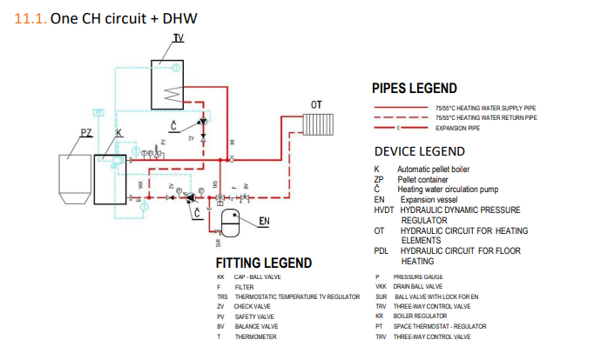

Two CH circuits + DHW

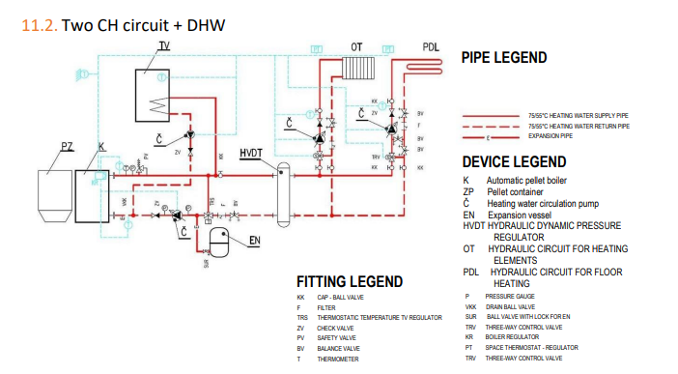

One CH circuit with 4-way valve + DHW
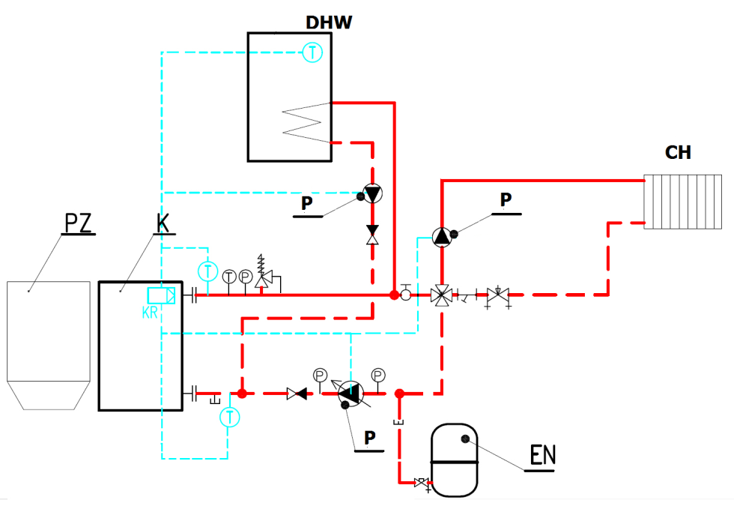

Buffer tank size determination
The use of a buffer tank is not required for Biopel MINI boilers. If you wish to use one in your heating system, please use the formula below to calculate the correct size of buffer tank for your boiler size.
Calculation of the smallest buffer tank volume:
Vsp = 15 Tb x Qn (1-0,3 x (QH/Qmin))
- Vsp ….. buffer tank volume in l
- Tb ...…. burning time in h
- Qn …… rated thermal power output in kW
- QH …… building heat load in kW
- Qmin … minimum heat power output in kW

The dimensions of the buffer tank must be determined according to the boiler power output. The pellet boiler does not require a buffer tank for its operation. There is no excess heat to be stored in the buffer tank. On the contrary, the boiler modulates its power output so that it never exceeds the set limit. If the boiler heats the heating system to the desired level, it switches off and on again when the temperature drops.
A buffer tank is recommended if the heating system contains more than one heating branch and generally for more complex heating systems with several heating circuits. We recommend that you consult a professional plumbing company or representatives of OPOP s.r.o. before purchasing a buffer tank.

REGULAR MAINTENANCE
Boiler maintenance is an integral part of solid fuel boiler operation. Recommended intervals for manual cleaning of the boiler, burner and flue. Please note that these intervals are only basic recommendations and may differ from the actual requirement for regular cleaning. The frequency of regular cleaning is mainly determined by the quality of the combustion process, the type and quality of pellets, the level of dust and moisture in the pellets, the chimney draft, etc. Therefore, always check the clogging rate of the boiler at short intervals during the first months of operation so that you can determine how often the boiler, burner and flue need to be cleaned according to the actual situation.
 | weekly | monthly | quarterly | annualy
ash container cleaning
burner grate cleaning
boiler exchanger cleaning
combustion check
Photosensor cleaning
door tightness check
complete burner cleaning
Feeder cleaning
hopper cleaning
flue gas outlet and chimney

- Cleaning the ash container is an essential step during regular boiler maintenance. Ensure correct positioning when placing it back on the boiler flange. There are two of these containers in the boiler, so clean them both regularly.
Do not overfill the container with ash which could clog the ash removal worm.
- The burner grate is removable and requires regular cleaning. During the first few weeks of operation, observe how often ash forms on the grate and scrape it off regularly with a cleaning tool. Only carry out this task when the boiler is deactivated (extinct).
- Clean the front of the boiler in the burner area as required at the same time as cleaning the burner grate.
- Cleaning of the flue gas turbulators and heat exchanger is an essential task. Ash on the heat exchanger grates reduces efficiency and in turn increases the temperature of the flue gas, i.e. more heat escapes up the chimney if the heat exchanger is contaminated with ash.
The flue gas swirlers are removable, we recommend checking the passage between the swirlers regularly and removing and cleaning them if necessary. The boiler heat exchanger can be accessed by removing the cleaning door at the top of the boiler.
- Once or twice a season, check the flue gas outlet for proper passage and clean it using the sweep hole that should be placed on the flue.
- Once a season, check the asbestos sealing cords on all doors for tightness. If they are hard and have lost their sealing ability, we recommend replacing them.
Ask your installation company to carefully explain how to clean the boiler and burner so that the boiler is operated in accordance with the instructions given. Regular cleaning of the boiler, burner and flue gas outlet will ensure maximum boiler efficiency and low fuel consumption during boiler operation.

BIOPEL ONLINE
Each Biopel MINI boiler can be connected to the OPOP online server free of charge, which runs an application for remote management of the boiler and heating system via the Internet using your web browser. Connecting the boiler to this online system is very simple, see points below.
- Connect the control unit to your internet receiver (modem or router). For the connector in the external socket, see the chapter Electrical connection of accessories.
- Display the Registration code in the settings of the v9 MINI control unit in the Registration function in the Installation menu, Ethernet module. Make a note of this registration code, you will need it later.
- This code has a limited validity, so after displaying the code, we recommend that you proceed immediately to register the boiler, see the next points in the procedure.
- Start the internet browser on your computer and enter the following address: opop.emodul.eu
- Click on New User and register the user to the OPOP online server.
- After successful registration, log in to the system using the username and password you chose earlier during the new user registration.
- Once connected, you must register your boiler by clicking on New Module in the Settings tab (top right).
- During the registration of the new module (boiler), enter all the information requested, including the registration code you copied down earlier.
- Once the module registration is saved, our online server connects to your boiler and all data from the boiler is uploaded to the server within seconds.
Now your boiler is fully connected to the OPOP online server and you can take full advantage of all the functions that remote boiler management via the internet offers. OPOP spol. s.r.o. technicians are ready to deal with any questions you may have.

FIRMWARE UPDATES
Each v9 MINI unit can be upgraded with a USB key. OPOP spol. s.r.o. regularly releases new versions of the unit software for free download. New versions usually contain new features and options that increase the automation of the boiler and provide more control options for the heating system. Consult the possibility of using new software updates with your installer or directly with an OPOP spol. s.r.o. representative. The installation procedure is very simple, see points below.
- Upload a file with the extension “.bin” to the USB key.
- Switch off the boiler using the main switch on the top of the boiler.
- Insert the USB key into the connector on the side of the display.
- Switch on the boiler using the main switch.
- Wait until the installation is complete (the unit displays the standard base panel) and remove the USB key.
- The v9 MINI control unit and the v9 MINI display are updated.

The USB key you are using must be formatted in the FAT32 file system for proper file upload. To check which file system your USB key is formatted in, right-click on the USB key icon in your computer's operating system and type Properties.
Caution: when uploading new software, the control unit settings will be reset to the original factory values. It is therefore necessary to perform all settings again, including the so-called first boiler start-up.

Risk analysis
Residual risks and their prevention. The risks arising from the operation of the boiler under conditions of expected use and reasonably foreseeable misuse have been minimised by available technical means. In spite of the design and technical measures implemented, certain residual risks remain in the operation of the boiler resulting from the risk analysis, which are determined by the technological process at different stages of the lifetime of the device.
This concerns in particular the risks caused by inattention of the boiler operator and failure to observe safety principles during operation. In order to further reduce the risks and to ensure a higher efficiency of safety protection, we draw attention to the possible occurrence of certain residual risks that cannot be eliminated by any technical solution.
Risks on delivery of the boiler and its accessories
Source of risk | Impact of the risk | Risk elimination
Vehicle - truck, personal car of technicians | Restrictions on the movement of employees (neighbours, family members) and machinery in the area where the equipment will be unloaded from the truck | Define the unloading area in advance and alert employees to this fact (neighbours, family members)
Handling trolley, forklift, truck arm or other means by which the equipment will be unloaded | Risk of injury or damage from parts of the equipment being moved | Carefully consider the strategy for unloading and transporting individual pieces of the equipment to the location where it will be temporarily stored or directly assembled
Storage of the equipment, whether folded or unfolded | Collision of persons, machines, vehicles, etc. with stored parts of the equipment. Condensation of water in the electrical installation and subsequent injury to the technician or damage to the equipment | The storage area shall be properly designated or secured and marked. The area must be kept dry to prevent moisture from reaching the wiring of the equipment
Risks involved in placing the boiler in its intended location and assembling it
Source of risk | Impact of the risk | Risk elimination
Handling trolley, forklift, or other means by which the equipment will be positioned | Risk of injury or damage from parts of the equipment being moved | Exercise extra caution when your employees, or you, are assisting our technicians
the assembly itself | Injuries caused by drills, angle grinders and common tools that technicians will use. E.g. hammer, screwdriver, file etc. Dropping a piece of the equipment. | If your employees, or you, will be assisting our technicians, make sure you have the proper protective equipment. For example, safety glasses, work gloves, etc. Exercise the utmost caution and foresight throughout the entire work
Risks during normal operation of the boiler and its accessories
Source of risk | Impact of the risk | Risk elimination
Boiler body | Burn when the door is open, scalding of the hands or face at the moment of opening | Open the door wearing protective gloves, the door is in direct contact with the flue gas and can reach temperatures of up to 400C. When opening this door, stand so that any escape of hot flue gases does not hit any part of the body. The danger lasts for a few seconds before the vacuum in the combustion chamber automatically equalizes
Ashtray | Hand injuries, burns from contact with an ashtray. Removing ashes from the ashtray. The boiler must not be in operation when emptying the ashtray! | Handle the ashtray only with protective gloves designed for this purpose. Empty the ashes only in the intended places. The ashes may still be hot, so only store the ashes in designated areas
Risks when maintaining the boiler and its accessories
Source of risk | Impact of the risk | Risk elimination
Combustion chamber | Burns, dust inhalation, dust in the eyes | If the boiler is not shut down long enough, parts of the boiler may still be hot, so wear protective gloves. When cleaning the combustion chamber, use protective glasses and a respirator. The recommended shutdown time is 4 hours.
Thermal risks
the boiler must not be subjected to a higher operating pressure than prescribed
it is forbidden to overheat the boiler
the boiler must be protected against low temperature corrosion by suitable connection with automatic return temperature protection
only the prescribed fuel may be burned in the boiler
it is forbidden to store combustibles in the vicinity of the boiler
Risks caused by fuel handling
The handling of fuel results in the emission of particulate matter. Therefore, the operator should use appropriate protective work equipment according to the degree of dustiness
As fuel is involved, the relevant fire regulations must be observed and a suitable fire extinguisher must be available
Ergonomic risks
the boiler must be in a horizontal position in the boiler room
all doors, lids and covers must be properly closed when the boiler is in operation

OPERATING AND ERROR MESSAGES
Below is a list of common queries we encounter. These relate to both the installation and operation of the boiler. Please read these questions carefully, they may help you in dealing with specific situations you may encounter.
- Alarm: Feeder sensor damaged
It concerns the protection sensor on the burner. Check the wiring of the sensor in the burner circuit board and in the control unit in the “Feeder sens.” output
- Alarm: CH sensor failure
CH sensor connected to the output “CH sens.” It is damaged or not connected.
- Alarm: DHW sensor failure
DHW sensor connected to “DHW sens.” output. It is damaged or not plugged in and one of the functions that needs it to work properly is activated.
- Alarm: CH temperature too high
TThe CH temperature measured by the CH sensor exceeded 93°C, i.e. the value set in the Max boiler temperature function in the Service menu.
- Alarm: DHW temperature too high
The DHW temperature measured by the DHW sensor has exceeded the maximum value set in the DHW Setpoint function in the Main Settings.
- Alarm: Termik sensor open
Termik sensor is not connected or is defective. Check the contact in the control unit.
- Alarm: Reverse flow sensor damaged
The return water sensor has been activated in the Built-in Mixing Valve 1 or 2 settings, but is defective or has not been connected to the output in the control unit called “Return sens.”.
- Alarm: Temperature sensor C1-C4 damaged
Temperature sensor has been activated but not connected to the unit to the appropriate output.
- Alarm: Mixing valve sensor failure
The built-in mixing valve 1 or 2 has been activated, but the valve 1 or 2 sensor has not been connected to the control unit to the “Valve 1, 2 sensor” output.

- Alarm: 3 ignitions in 30 min.
The boiler ignites too often. Check the correctness of the flame detection by the photosensor after ignition. If the photosensor does not see the light, the boiler goes into normal operation.
- Message: No communication with room thermostat
The RT10 room thermostat has not been connected but it is activated. Check the thermostat settings.
- Message: No communication with Lamba sensor
The lambda probe was not connected or wrong but is activated. Check the Lambda settings in the Installation menu, Lambda and check the Lambda probe connection.
- Message: Temperature reached
The boiler was switched off by reaching the CH temperature.
- Message: DHW heated
The DHW temperature has been reached. The DHW pump has been switched off.
- Alarm: Outdoor sensor failure
The outdoor temperature sensor has been activated in the settings for built-in mixing valve 1 or 2, but is not connected to the external boiler socket to the “Weather sens.” output.
- Alarm: Mosfet sensor damaged
The Mosfet component is responsible for fan speed control and probably got overheated. Check the supply voltage, which should be no higher than 240V. If all is well, then the fan got stuck or scrapping. Check the fan operation and the functionality of the start-up fan, which is located on the burner.
- Alarm: Mosfet temperature too high or incorrect airflow
The temperature at the component measuring the fan speed and current draw is too high. Check the fan operation and the fan start-up capacitor to see if they are OK.
- Feeder temperature too high
The temperature in the burner exceeded 80°C. Check correct grate placement, operation of the internal feeder using manual operation in the Installation Menu. Check the flue gas outlet passage.
- Alarm: Unsuccessful ignition
The ignition cartridge is defective or the ignition process is incorrectly set. Make sure that after the flame is formed, it is detected by the photosensor.
- Alarm: Temperature not rising
If the CH temperature does not exceed 30°C in 30 min after ignition, an alarm message appears. Set in the service menu, in the functions Min. temperature alarm, Min. temperature time.

TROUBLESHOOTING OF SPECIFIC SITUATIONS
Below you will find a list of common queries we encounter. They relate to both the installation and operation of the boiler. Please read these questions carefully, as they may help you in dealing with specific situations you may encounter.
- Incorrect flame at max. power:
  - Flame extension: Service menu, Feeder settings, Work
    - Max feed work – set longer feeder run time
    - Min feed pause – set shorter feeding pause time
  - Flame Shortening: Service Menu, Feeder Settings, Work
    - Max feed work – set a shorter feeder run time
    - Min feed pause – set a longer feeding pause time
  - Reducing the amount of air: Service menu, Feeder settings, Work
    - Max fan power – set a lower number
  - Increasing air quantity: Service menu, Feeder settings, Work
    - Max fan power – set a higher number

These changes can be used to adjust the flame size and thus the combustion quality. After the ignition phase, wait 10 minutes for the burner to reach its maximum power output and then you can make changes.
- Incorrect flame at min. power:
  - Reducing the boiler power to the minimum:
Wait until the CH temperature is close to the set value, or set the same values in Service menu, Feeder settings, Work, for min and max power. Example:
    - Service menu: Feeder settings, Work, for min. and max. power:
      - Max feeding work = 2s (value for max. power)
      - Min feeding work = 2s (value for min. power)
      - Max feeding pause = 10s (value for min. power)
      - Min feeding pause = 10s (value for max. power)
Now the same values are set for the feeder operation at minimum and maximum power. Wait 10mins for the flame to stabilise and make any corrections, see below.
  - Flame extension: Service menu, Feeder setting, Work
    - Min. feed work – set a higher feeder operating number
    - Max. feeding pause – set a shorter feeding pause time
  - Flame shortening: Service menu, Feeder setting, Work
    - Min. feed work – set a lower feeder operating number
    - Max. feeding pause – set a longer feeding pause time.
  - Reducing air quantity: Service menu, Feeder setting, Work
    - Min. fan speed operation – set a lower number
  - Increasing air quantity: Service menu, Feeder setting, Work
    - Min. fan speed operation – set a higher number
It is important that the flame is stable during minimum power output and that there is no risk of extinction during boiler operation.

- Unburnt pellets in the ashtray:
  - Reduce fan speed: Service menu, Feeder settings, Work
    - Max. fan power – set a lower number
  - Reduce feeder operating time: Service menu, Feeder settings, Work
    - Max. feeding work – set a lower number
    - Min. feeding pause – set a higher number

- Long or failed ignition:
  - High chimney draft - Chimney draft is a major factor that can affect the ignition cycle time. This time is normally 4 to 6 minutes. Chimney draught higher than 15Pa negatively affects the resulting ignition time. The solution is to install a draft stabiliser. Keep also in mind that the higher the boiler power, the more likely it is to affect the ignition time.
We recommend installing a draft stabilizer for each boiler. Furthermore, the draft stabilizer must be adjusted as indicated in the boiler parameters table - chimney draft.
  - Quantity of pellets on the grate: Service menu, Feeder settings, Ignition
    - Dose time – set a higher or lower number. The pellets should cover the opening of the ignition cartridge, which is above the grate, but in general, the fewer the pellets on the grate during ignition, the faster the ignition cycle itself.
  - Poor fan speed: Service menu, Feeder settings, Ignition
    - Fan speed ½ – set a lower or higher speed. A trained installer knows the recommended values.

- Photosensor does not see the flame:
  - Sensitivity: Service menu, Feeder settings, Ignition
    - Brightness – set a lower number for higher sensitivity and vice versa. The minimum number should be around 30. If it is lower you risk that the photosensor will see the ambient light without there being a flame in the boiler.
  - Bad contact in the burner socket
    - If the message Damaged feeder sensor appears on the display, it means that the socket on the burner is incorrectly connected or damaged. Check the inside of both burner sockets.
  - Can not see the light during ignition
    - The flame is too small or the pellets block the flame detection in the burner. You need to extend the operating time of the internal feeder so that there are none left in the burner and they all reach the burner grate.

- Failed SW update:
  - USB must be formatted in FAT32 file system
  - or the USB file is damaged.
We recommend reformatting the USB and uploading the update file. Or replace the USB key with another one.

- No PID regulation:
  - The CH sensor or flue gas sensor is not connected.
  - Flue gas temperature is higher than 170°C.
  - PID regulation is affected by the rate of temperature change over time, so each system is likely to respond differently.

- Lambda probe reduces boiler power:
  - Change the modulation range in the Installation menu, Lambda. The factory setting is -15 to +15. It is necessary to reduce this range.
  - Leaks in the flue pipe joints and in the lambda sensor pit. False air is being drawn in, the lambda is trying to regulate it.

- Lambda probe degrades combustion quality:
  - If the flame after activating the Lambda probe is consistently large and dark (i.e. not enough combustion air) then it means that the Lambda probe is measuring a large amount of excess air and trying to reduce it to the set limit by adding fuel or reducing fan speed.
  - This may be due to a leak in some part of the flue pipe, the boiler or the lambda sensor hole. These leaks allow additional air to enter the boiler, which the lambda probe tries to eliminate in the aforementioned way. The only place where air enters the boiler should be the burner fan.
  - Similarly, reduce also the modulation range that the Lambda probe can do in the Min. change and Max. change items in the Installation menu, Lambda.

- The data changed on the internet will be uploaded to the boiler only after a long time:
  - Normally with a good internet connection it takes 1 minute to upload data from the internet to the boiler unit.
  - If the data is uploaded e.g. in 10 minutes or more, it means that the internet connection is bad or one of the additional devices is activated and not connected to the external socket: RT10 room thermostat, Lambda probe, 431N module. Connect these additional devices or deactivate them in the settings of the additional device.

- When the cause of the alarm is removed, it will reappear
  - The unit has fixed detection of possible alarms at 15s. If you remove the cause of an alarm after the last detection, the alarm may still occur again after the cause is deactivated. After reconfirmation, the alarm will no longer appear if the cause of the alarm has indeed been removed.
- Failed synchronisation
- The unit synchronizes data with the control unit at start-up.
- If the synchronization fails, the cause is inconsistent SW in the display and control unit. Upload the latest version of SW to both devices.

- Clogged grate of the burner:
  - Clogged grate with unburnt pellets, too much ash on the grate.
  - External feeder dosing time too long. Reduce the Max. feeder coefficient in the Coefficients function in the Installation Menu. If necessary, re-adjust the value in Max feeder coefficient after some time.
  - Low fan speed. Increase the Max Fan Coefficient in the Coefficients function in the Installation Menu.
  - Wrong type of pellets that are not 100% wood, the type of wood does not matter.
  - High moisture content in the pellets, the pellets only burn on the surface and do not burn further.
  - Incorrect grate position in the burner, clogged burner grate holes.
  - Lower than required chimney draft.
  - Large amount of dust in the pellets.

- High temperature of the internal feeder in the burner:
  - Displayed in the bottom left corner of the v9 MINI main panel.
  - The standard value is up to 50°C.
  - Possible causes are:
    - Clogged grate due to poor combustion or wrong fuel type.
    - Incorrect grate position in the burner, clogged burner grate holes.
    - Lower than required chimney draft.
    - Clogged boiler or flue gas path.
  - There is a risk of backfiring into the back of the burner, remedial action must be arranged.

FACTORY SETTINGS
All factory settings based on boiler size can be found in the table below. These values are saved in the operating memory of the control unit after entering the boiler power output during the first boiler start-up.
Ignition parameters: | 100kW | 150kW | 200kW
Blowing time
Blowing speed
Feed (hopper) time
Ignition delay
Feeding time
Feeding pause
Fan speed
Fan speed 2
Heater protection
Ignition brightness
Fan delay

Operating parameters: | 100kW | 150kW | 200kW
Min feeder operation | 1s | 2s | 3s
Max feeder operation | 5s | 4s | 6s
Min feeder pause | 12s | 5s | 4s
Max feeder pause | 10s | 13s | 14s
Min fan speed - operation | 30% | 18% | 24%
Max fan speed - operation | 60% | 35% | 45%
Cleaning period
Operation check

Exctinction parameters: | 100kW | 150kW | 200kW
Fan speed
Feeding time
Feeding pause
Exctinction time
Delay time

Service menu: | 100kW | 150kW | 200kW
Max flue gas temperature
Feeder alarm temperature
Priority temperature
CH pump emergency activation
Boiler alarm temperature
Internal feeder coefficient
Min boiler temperature
Pump swich-on temperature
Growth impulses
Supervision temperature
Boiler hysteresis
DHW hysteresis

Main settings, Burner cleaning: | 100kW | 150kW | 200kW
On
Cleaning period
Fan operating time
Blowing intensity

Installation menu, Lambda: | 100kW | 150kW | 200kW
Time of the first update
Update period
Oxygen surge
Fan surge
Sum
Min change
Max change
Lambda 100%
Lambda 1%

Installation menu, Compressor 1:  (burner) | 100kW | 150kW | 200kW
Cleaning period | 3min | 3min | 3min
Opening time | 2s | 2s | 2s
Cycle time | 25s | 25s | 25s
Pause time | 20h | 20h | 20h

Installation menu, Vacuum feeder: | 100kW | 150kW | 200kW
Operating time
Switch-on hour
Switch-on hour 2
Opening time
Pause time

Installation menu, Ash remover: | 100kW | 150kW | 200kW
Operating time | 10min | 10min | 10min
Pause time | 30min | 20min | 20min
Installation menu, Compressor 2,3,4,5 : (exchanger) | 100kW | 150kW | 200kW
Cleaning period | 3min | 3min | 3min
Opening time | 6s | 6s | 6s
Cycle tine | 40s | 40s | 40s
Pause time | 4h | 4h | 4h

These values can only be changed by a certified installer who is authorized to install and start up OPOP s.r.o. boilers.
The information in the tables serves for better orientation in the Service menu items and simplifies the clarity of the set values during the selection of the power output during the first start-up of the boiler.
Changing these parameters has a major effect on the boiler operation. If you need to reset the settings to the default values shown in the table, you can perform the first start-up of the boiler again, or use the Factory settings function in the Main, Installation and Service menus to reset to factory settings.

ENERGY EFFICIENCY

I. | II. | III. | IV. | V. | VI.
name or trademark of the supplier; | supplier's model identification mark; | energy efficiency class | rated thermal power in kW, | energy efficiency index | seasonal heating energy efficiency in %
OPOP s.r.o. | Biopel 100 | A+ | 100 | 118 | 80
OPOP s.r.o. | Biopel 150 | A+ | 150
OPOP s.r.o. | Biopel 200 | A+ | 200 | 119 | 81

IDENTIFICATION MARKS

model identification mark: BIOPEL MINI 100
Condensing boiler: |  |  |  |  | no |  |  | Solid fuel cogeneration boiler: |  |  |  | no |  | Combined boiler: |  |  | no
Feeding mode: automatic |  |  |  |  | Manual: the boiler should be operated with a hot water tank of at least x(*) litres/ Automatic: it is recommended that the boiler is operated with a hot water tank of at least x(**) litres]
Fuel |  |  |  |  |  |  |  |  |  |  |  | Preferred fuel (one only): |  |  | Other suitable fuel(s):
Wood logs, moisture content ≤ 25 % |  |  |  |  |  |  |  |  |  |  |  | no |  |  | no
Wood chips, moisture content 15–35 % |  |  |  |  |  |  |  |  |  |  |  | no |  |  | no
Wood chips, moisture content > 35 % |  |  |  |  |  |  |  |  |  |  |  | no |  |  | no
Pressed wood in the form of pellets or briquettes |  |  |  |  |  |  |  |  |  |  |  | yes |  |  | no
Sawdust, moisture content ≤ 50 % |  |  |  |  |  |  |  |  |  |  |  | no |  |  | no
Other woody biomass |  |  |  |  |  |  |  |  |  |  |  | no |  |  | no
Non-wood biomass |  |  |  |  |  |  |  |  |  |  |  | no |  |  | no
Black coal |  |  |  |  |  |  |  |  |  |  |  | no |  |  | no
Brown coal (including briquettes) |  |  |  |  |  |  |  |  |  |  |  | no |  |  | no
Coke |  |  |  |  |  |  |  |  |  |  |  | no |  |  | no
Anthracite |  |  |  |  |  |  |  |  |  |  |  | no |  |  | no
Briquettes from a mixture of fossil fuels |  |  |  |  |  |  |  |  |  |  |  | no |  |  | no
Other fossil fuel |  |  |  |  |  |  |  |  |  |  |  | no |  |  | no
Briquettes from a mixture of biomass (30-70 %) and fossil fuels |  |  |  |  |  |  |  |  |  |  |  | no |  |  | no
Other mixture of biomass and fossil fuels |  |  |  |  |  |  |  |  |  |  |  | no |  |  | no
Properties when operating with preferred fuel:
Seasonal indoor heating energy efficiency ηs [%]: |  |  |  |  |  |  |  |  |  |  |  | 80
Energy Efficiency Index EEI: |  |  |  |  |  |  |  |  |  |  |  | 118
Energy Efficiency Class: |  |  |  |  |  |  |  |  |  |  |  | A+
Name |  |  | Designation |  | Value |  |  | Unit |  |  |  | Name |  | Designation | Value |  | Unit
Rated thermal power output |  |  |  |  |  |  |  |  |  |  |  | Rated efficiency
At nominal thermal power |  |  | Pn(***) |  | 98,3 |  |  | kW |  |  |  | At nominal thermal power |  | ηn | 84,4 |  | %
At [30 %] of rated thermal power, if applicable |  |  | Pp |  | 29,0 |  |  | kW |  |  |  | At [30 %] of rated thermal power, if applicable |  | ηp | 83,7 |  | %
Solid fuel cogeneration boilers: Electrical efficiency |  |  |  |  |  |  |  |  |  |  |  | Auxiliary electricity consumption
At nominal thermal power |  |  | ηel,n |  | - |  |  | % |  |  |  | At nominal thermal power |  | elmax | 0,128 |  | kW
 |  |  |  |  |  |  |  |  |  |  |  | At [30 %] of rated thermal power, if applicable |  | elmin | 0,061 |  | kW
 |  |  |  |  |  |  |  |  |  |  |  | Of the built-in secondary emission abatement equipment, if applicable |  |  | not applicable |  | kW
 |  |  |  |  |  |  |  |  |  |  |  | In standby mode |  | PSB | 0,004 |  | kW
Contact details |  |  |  |  | OPOP s.r.o. , Zašovská 750, Valašské Meziříčí, 757 01
(*) Tank volume = 45 × Pr × (1 – 2,7/Pr) or 300 litres, whichever is the higher whereas Pr is expressed in kW
(**) Tank volume = 20 × Pr whereas Pr is expressed in kW
(***) For the preferred fuel, Pn is equal to Pr
model identification mark: BIOPEL MINI 150
Condensing boiler: |  | no |  | Solid fuel cogeneration boiler: |  |  | no |  | Combined boiler: |  |  |  |  |  |  | no
Feeding mode: automatic |  | Manual: the boiler should be operated with a hot water tank of at least x(*) litres/  Automatic: it is recommend that the boiler is operated with a hot water tank of at least x(**) litres]
Fuel |  |  |  |  |  |  | Preferred fuel (one only): |  |  |  |  |  | Other suitable fuel(s):
Wood logs, moisture content ≤ 25 % |  |  |  |  |  |  | no |  |  |  |  |  | no
Wood chips, moisture content 15–35 % |  |  |  |  |  |  | no |  |  |  |  |  | no
Wood chips, moisture content > 35 % |  |  |  |  |  |  | no |  |  |  |  |  | no
Pressed wood in the form of pellets or briquettes |  |  |  |  |  |  | yes |  |  |  |  |  | no
Sawdust, moisture content ≤ 50 % |  |  |  |  |  |  | no |  |  |  |  |  | no
Other woody biomass |  |  |  |  |  |  | no |  |  |  |  |  | no
Non-wood biomass |  |  |  |  |  |  | no |  |  |  |  |  | no
Black coal |  |  |  |  |  |  | no |  |  |  |  |  | no
Brown coal (including briquettes) |  |  |  |  |  |  | no |  |  |  |  |  | no
Coke |  |  |  |  |  |  | no |  |  |  |  |  | no
Anthracite |  |  |  |  |  |  | no |  |  |  |  |  | no
Briquettes from a mixture of fossil fuels |  |  |  |  |  |  | no |  |  |  |  |  | no
Other fossil fuel |  |  |  |  |  |  | no |  |  |  |  |  | no
Briquettes from a mixture of biomass (30-70 %) and fossil fuels |  |  |  |  |  |  | no |  |  |  |  |  | no
Other mixture of biomass and fossil fuels |  |  |  |  |  |  | no |  |  |  |  |  | no
Properties when operating with preferred fuel:
Seasonal indoor heating energy efficiency ηs [%]: |  |  |  |  |  |  | 81
Energy Efficiency Index EEI: |  |  |  |  |  |  | 119
Energy Efficiency Class: |  |  |  |  |  |  | A+
Name | Designation | Value |  | Unit |  |  | Name |  | Designation |  |  |  | Value |  |  | Unit
Rated thermal power output |  |  |  |  |  |  | Rated efficiency
At nominal thermal power | Pn(***) | 150 |  | kW |  |  | At nominal thermal power |  | ηn |  |  |  | 84,5 |  |  | %
At [30 %] of rated thermal power, if applicable | Pp | 45 |  | kW |  |  | At [30 %] of rated thermal power, if applicable |  | ηp |  |  |  | 84,2 |  |  | %
Solid fuel cogeneration boilers: Electrical efficiency |  |  |  |  |  |  | Auxiliary electricity consumption
At nominal thermal power | ηel,n |  |  | % |  |  | At nominal thermal power |  | elmax |  |  |  | 0,180 |  |  | kW
 |  |  |  |  |  |  | At [30 %] of rated thermal power, if applicable |  | elmin |  |  |  | 0,084 |  |  | kW
 |  |  |  |  |  |  | Of the built-in secondary emission abatement equipment, if applicable |  |  |  |  |  | not applicable |  |  | kW
 |  |  |  |  |  |  | In standby mode |  | PSB |  |  |  | 0,004 |  |  | kW
Contact details |  | OPOP s.r.o. , Zašovská 750, Valašské Meziříčí, 757 01
(*) Tank volume = 45 × Pr × (1 – 2,7/Pr) or 300 litres, whichever is the higher whereas Pr is expressed in kW
(**) Tank volume = 20 × Pr whereas Pr is expressed in kW
(***) For the preferred fuel, Pn is equal to Pr
model identification mark: BIOPEL MINI 200
Condensing boiler: |  | no |  |  | Solid fuel cogeneration boiler: |  | no |  |  | Combined boiler: |  |  |  |  |  | no
Feeding mode: automatic |  | Manual: the boiler should be operated with a hot water tank of at least x(*) litres/  Automatic: it is recommend that the boiler is operated with a hot water tank of at least x(**) litres]
Fuel |  |  |  |  |  |  | Preferred fuel (one only): |  |  |  |  |  | Other suitable fuel(s):
Wood logs, moisture content ≤ 25 % |  |  |  |  |  |  | no |  |  |  |  |  | no
Wood chips, moisture content 15–35 % |  |  |  |  |  |  | no |  |  |  |  |  | no
Wood chips, moisture content > 35 % |  |  |  |  |  |  | no |  |  |  |  |  | no
Pressed wood in the form of pellets or briquettes |  |  |  |  |  |  | yes |  |  |  |  |  | no
Sawdust, moisture content ≤ 50 % |  |  |  |  |  |  | no |  |  |  |  |  | no
Other woody biomass |  |  |  |  |  |  | no |  |  |  |  |  | no
Non-wood biomass |  |  |  |  |  |  | no |  |  |  |  |  | no
Black coal |  |  |  |  |  |  | no |  |  |  |  |  | no
Brown coal (including briquettes) |  |  |  |  |  |  | no |  |  |  |  |  | no
Coke |  |  |  |  |  |  | no |  |  |  |  |  | no
Anthracite |  |  |  |  |  |  | no |  |  |  |  |  | no
Briquettes from a mixture of fossil fuels |  |  |  |  |  |  | no |  |  |  |  |  | no
Other fossil fuel |  |  |  |  |  |  | no |  |  |  |  |  | no
Briquettes from a mixture of biomass (30-70 %) and fossil fuels |  |  |  |  |  |  | no |  |  |  |  |  | no
Other mixture of biomass and fossil fuels |  |  |  |  |  |  | no |  |  |  |  |  | no
Properties when operating with preferred fuel:
Seasonal indoor heating energy efficiency ηs [%]: |  |  |  |  |  |  | 81
Energy Efficiency Index EEI: |  |  |  |  |  |  | 119
Energy Efficiency Class: |  |  |  |  |  |  | A+
Name | Designation | Value |  |  | Unit |  | Name |  |  | Designation |  |  | Value |  |  | Unit
Rated thermal power output |  |  |  |  |  |  | Rated efficiency
At nominal thermal power | Pn(***) | 202,3 |  |  | kW |  | At nominal thermal power |  |  | ηn |  |  | 84,6 |  |  | %
At [30 %] of rated thermal power, if applicable | Pp | 56,8 |  |  | kW |  | At [30 %] of rated thermal power, if applicable |  |  | ηp |  |  | 84,7 |  |  | %
Solid fuel cogeneration boilers: Electrical efficiency |  |  |  |  |  |  | Auxiliary electricity consumption
At nominal thermal power | ηel,n |  |  |  | % |  | At nominal thermal power |  |  | elmax |  |  | 0,220 |  |  | kW
 |  |  |  |  |  |  | At [30 %] of rated thermal power, if applicable |  |  | elmin |  |  | 0,100 |  |  | kW
 |  |  |  |  |  |  | Of the built-in secondary emission abatement equipment, if applicable |  |  |  |  |  | nepoužije se |  |  | kW
 |  |  |  |  |  |  | In standby mode |  |  | PSB |  |  | 0,004 |  |  | kW
Contact details |  | OPOP s.r.o. , Zašovská 750, Valašské Meziříčí, 757 01
(*) Tank volume = 45 × Pr × (1 – 2,7/Pr) or 300 litres, whichever is the higher whereas Pr is expressed in kW
(**) Tank volume = 20 × Pr whereas Pr is expressed in kW
(***)For the preferred fuel, Pn is equal to Pr

WARRANTY CONDITIONS, GENERAL INSTRUCTIONS
The information provided below must be met not only to comply with the warranty conditions, but also to ensure that the installation is correct in terms of applicable standards, safety and to ensure trouble-free operation of the boiler.
- Biopel MINI boilers may only be installed by a company with a valid installation and maintenance licence. The installation must be designed in accordance with the applicable regulations.
- The heating system must be filled with water that meets the requirements of ČSN 07 7401 and in particular its hardness must not exceed the required parameters. The use of antifreeze mixtures is not recommended by the manufacturer.
- The connection of the boiler to the system must be made in accordance with the applicable regulations and standards.
- The flue gas pipe must be inspected by a chimney inspection company before the boiler is installed. An inspection report must be drawn up covering the basic parameters of the flue gas pipe including the diameter of the chimney, its length and the chimney draft.
- The flue pipe must not be longer than 1m and must be fitted with a clean-out hole. The flue pipe may only be longer if the chimney draft has been measured and recorded no further than 30cm from the boiler and if it meets the minimum operating draft requirements, see chapter Main parameters and dimensions.
- The Biopel boiler must be installed in a separate boiler room specially adapted for heating. The boiler room must have sufficient space for the installation and maintenance of the boiler. Adequate fresh air circulation for combustion must be ensured.
- The boiler must never be installed in open spaces or balconies, in areas occupied by people such as the kitchen, living room, bathroom, bedroom, in areas where explosive and flammable materials are present.
- It is recommended to install the boiler on a concrete base made of fireproof material.
- There must be a minimum clearance around the boiler and the pellet hopper: 60cm from the rear and sides, 100cm from the front of the boiler and hopper.
- A safe distance of 200mm from combustible materials must be maintained during installation and operation of the boiler.
- It is forbidden to store fuel behind the boiler or to stack it next to the boiler at a distance of less than 800 mm.
- It is forbidden to store the fuel between two boilers in the boiler room.
- The distance between the boiler and the fuel must be at least 1000 mm or you should place the fuel in a different room than the boiler is installed.
- The warranty fuel is considered to be wood pellets only, with a diameter of 6mm or more, with the parameters specified in the instructions for use.
- The manufacturer is not liable for the quality of the fuel, in terms of combustion quality, ash quantity or frequency of boiler cleaning due to the fact that these facts are only influenced by external factors such as pellet quality, dust and moisture in the pellets, chimney draft or correct combustion settings.
- It is forbidden to use flammable liquids (petrol, alcohol, etc.) to fire the boiler.
- It is forbidden to overheat the boiler in any way during operation.
- If there is a risk of flammable vapours or gases entering the boiler room or during work that creates a temporary risk of fire or explosion (gluing of floor coverings, painting with flammable paints, etc.), the boiler must be shut down in time before work begins.
- After the end of the heating season, the boiler must be thoroughly cleaned, including the flue pipe. The boiler room must be kept clean and dry.
- It is forbidden to interfere with the construction and electrical installation of the boiler.
- The manufacturer is not liable for damage caused by improper adjustment or improper operation of the product.
- Parts subject to wear and tear are not covered by the standard warranty period. These parts are: sealing cord, grenamata plate, ignition cartridge, burner grate, lambda probe. However, these parts will function for a long time if the boiler and its components are operated in accordance with the instructions for use. These parts are considered as consumables and are covered by the manufacturer's warranty of 6 months.
- The manufacturer is not responsible for rust on the boiler and its components, as this is always and only due to external influences such as humidity in the room, fuel or due to unprofessional installation without protection of the boiler against low temperature corrosion.
- The boiler must be protected against low return water temperature by means of a valve which prevents cold water from entering the boiler. The minimum acceptable return water temperature is set by the manufacturer at 55°C.
- The manufacturer is not responsible for condensation of cold air in the flue gas passage, as this must be prevented by correct installation of the flue gas passage and correct adjustment of the boiler combustion process.
- The manufacturer is not liable for smoke leakage from the boiler into the room if this is caused by low chimney draught, incorrect installation of the boiler or incorrect adjustment of the combustion process.
- The manufacturer shall not be liable for damage to parts caused by handling, transport, incorrect adjustment or misuse or other external fault not directly related to the function of the individual boiler components.
- The installation of the boiler, the boiler additional devices and the correct set-up and start-up of the boiler are always the responsibility of the installer who sold the boiler to the end customer.
- If it has been agreed that a third party (e.g. the company performing the first start-up) holds the warranty conditions, then this must be stated and agreed by 3 parties, namely the boiler dealer, the boiler commissioning company and the end customer. All of the above mentioned parties must agree to this and it must be stated so with the signatures of all of them in the warranty addendum.
- The manufacturer is not responsible for incorrect selection of the boiler power output in relation to the heating losses of the building (e.g. positioning the boiler with too small or too large power output in relation to the need).

APPLICABLE STANDARDS AND REGULATIONS
Applicable standards that must be observed during installation and operation of the boiler. This information is intended for plumbing companies carrying out the installation and commissioning of the boiler.
Heating system:
The heating system must be filled with water that meets the requirements of ČSN 07 7401 and in particular its hardness must not exceed the required parameters: Hardness = 1mmol/l, Ca2+ = 0.3mmol/l, concentration of total Fe+Mn = 0.3mg/l.

ČSN 06 0310 Thermal systems in buildings – Design and installation
ČSN 06 0830 Thermal systems in buildings – Safety devices
ČSN 07 7401 Water and steam for thermal energy installations with working steam pressure up to 8 MPa.
ČSN EN 303-5+A1 Boilers for central heating – Part 5: Solid fuel-fired central heating boilers, with manual or automatic delivery, with a rated thermal input not exceeding 500 kW – Terminology, requirements, testing and marking.

Flue gas system:
ČSN 73 4201 Designing chimneys and flues.

Fire regulation:
ČSN 06 1008 Fire protection of heating appliances.
ČSN EN 13 501-1+A1 Fire classification of construction products and building elements - Part 1: Classification using test data from reaction to fire.

Electrical network:
ČSN 33 0165 ED.2 Marking the conductors with colours or digits. Implementing regulations.
ČSN 33 1500 Revision of electrical devices.
ČSN 33 2000-1 ED.2 Low-voltage electrical installations - Part 1: Basic aspects, determination of basic characteristics, definitions
ČSN 33 2000-4-41 ED.3 Low-voltage electrical installations - Part 4-41: Protective measures to ensure safety - Protection against electric shock
ČSN 33 2000-5-51 ED.3+Z1+Z2 Low-voltage electrical installations - Part 5-51: Selection and construction of electrical installations - General rules
ČSN 33 2130 ED.3 Low Voltage Electrical Installations - Indoor electrical wiring
ČSN 33 2180 Connecting electrical devices and appliances.
ČSN 34 0350 ED.2 Safety requirements for moving leads and cord lines.
ČSN EN 60079-10-1 ED.3 Explosive atmospheres - Part 10-1: Determination of hazardous areas - Explosive gaseous atmospheres.
ČSN EN 60 079-14 ED.4 Explosive atmospheres - Part 14: Design, selection and installation of electrical installations.
ČSN EN 60335-1 ED.2 Household and similar electrical appliances - Safety - Part 1: General requirements.
ČSN EN 60335-2-10 ED.2 Household and similar electrical appliances - Safety - Part 2-10: Particular requirements for floor-care and wet-brushing appliances.
ČSN EN 60445 ED.5 Basic and safety principles for man-machine interface, marking and identification - Identification of object terminals, wire ends and conductors.
ČSN EN IEC 61000 – 6 – 3 ED.3 Electromagnetic compatibility (EMC) - Part 6-3: Generic standards - Emission standard for equipment in the residential environment.
ČSN EN 61000 - 1 – 2 Electromagnetic compatibility (EMC) - Part 1-2: General - Methodology for achieving functional safety of electrical and electronic systems with respect to electromagnetic phenomena.
ČSN EN 61000 – 3 –3 ED.3
Electromagnetic compatibility (EMC) - Part 3-3: Limits - Limitation of voltage variation, voltage fluctuation and flicker in low-voltage distribution systems for equipment with rated phase current <= 16 A not subject to conditional connection

DHW heating system:
ČSN 06 0320 Thermal systems in buildings - Hot water preparation - Design and planning.
ČSN 06 0830 Thermal systems in buildings - Safety equipment.
ČSN 75 5409 Internal water pipelines.

Placement options:
ČSN 06 1008 Fire safety of thermal equipment.
ČSN EN 13 501-1 Fire classification of construction products and structures of buildings - Part 1: Classification by reaction to fire test results.
ČSN 33 2000-1 ED.2 Elektrické instalace nízkého napětí - Část 1: Základní hlediska, stanovení základních charakteristik, definice

WARRANTY CARD

Biopel MINI 100,150,200

Manufacturer: OPOP s r.o., Valašské Meziříčí, Czech Republic
Tel.: 00420 571 675 589, fax.: 00420 571 611 225

Instructions on the complaints procedure:
The user is obliged to entrust commissioning, regular maintenance and fault rectification only to a professional service. This warranty card contains a certificate of quality and completeness. The manufacturer confirms that the product has been inspected and conforms in design to the technical specifications and ČSN EN 303-5+A1. We warrant the quality, function and performance of the boiler for a period of 24 months from the date of sale to the relevant consumer, but no longer than 30 months from the date of removal from the factory, on the condition that any defects resulting from proven faulty material, faulty construction or faulty design are rectified at our expense as soon as possible, provided that the product:
- it is in normal working order according to the operating instructions and is operated in accordance with the operating instructions.
- it has not been mechanically damaged by force (no unauthorised intervention except as permitted in the operating instructions).
- the consumer presents this warranty card, duly completed, when making a claim.
- the manufacturer's instructions for use of the equipment have been followed.
- if the purchaser fails to sell the product within the above-mentioned statutory warranty period, all liability for any defect in the product shall be borne by the purchaser.
- it is connected to the chimney flue according to ČSN 73 4201/2010.
- the costs associated with the handling of the complaint will be recharged to the customer.
- when reporting a defect, it is always necessary to present this warranty card, give the exact address and state the circumstances under which the defect occurred. The method and place of repair will be decided by our company.

We guarantee the permanent tightness of the steel weldment for a standard period of two years from the date of removal from the production plant. We guarantee a 60-month warranty if the required temperature range of the heating water is ensured and the leakage was caused by poor quality material or welding work.
In order for the warranty of a flowing steel weldment to be accepted, it must be clearly demonstrated that the water in the boiler is not due to condensation of cooled air, but to leakage of the weldment. The guarantee cannot be accepted in the event of faults caused by the operator or when the boiler is connected to a heating system which does not meet the basic operating conditions of the boiler. If the warranty is accepted during the extended warranty period, we will deliver the replacement weldment by piece transport or by means of a personal collection to the user.

If the defective weldment is not returned to the manufacturing company within 30 days of the date of shipment or delivery of the replacement weldment, the user will be charged for the full amount of the weldment, including the cost of shipping the new weldment.

A weldment replaced within the extended warranty period of 60 months is covered by a warranty of 24 months from the date of removal. The boiler weldment is sprayed with black, water-based paint, which may result in peeling of this paint. Peeling paint does not affect the function of the boiler. This paint will be scorched after the first boiler ignition. The extra warranty is held by OPOP if the plumbing company has completed the Extension Warranty Card regularly for years 3 through 5 as described on the following pages of this manual. In the case of a flowing steel weldment, the customer will be asked to provide a properly completed Warranty Extension Card.

Date and manufacturer´s stamp: Date and stamp of the plumber:
(boiler manufacture) (stamp of the plumbing company that executed the sale of the boiler)

Extension of the warranty period for the steel weldment tightness

Customer name: ___________________________ Boiler name: ____________________________
Address: ___________________________________ Serial number: ___________________________
City: ___________________________________ Installation date: _________________________

Answer Yes or No to all questions or provide a value for each parameter each year. Provide additional information if necessary. Indicate the date of the inspection at the end.
Text colour indicates visual inspection Text colour indicates flood test inspection

Question: | First start | Year +1 | Year +2 | Year +3 | If NO, then please state the reason
Is the boiler used at a maximum operating pressure of up to 2 bar?
Is the safety valve used up to a maximum of 2 bar?
Is the return water temperature during boiler operation 55°C or more?
Is a 3-way or 4-way valve used as protection against low temperature corrosion?
Is the boiler installed and started up by a certified company? |  |  |  |  | Company name:
Is the boiler operated according to the conditions specified in the operating instructions?
Is the boiler and burner clean?
Is the boiler dry inside?
Is regular annual servicing carried out?
Are the temperature sensors installed in accordance with the installation manual?
Is only warranty fuel used?
Is the combustion and flame correct?
Is the warranty extended? (yes/no)
Inspection date

Service centre: ___________________ ___________________ ___________________
Year +1 Year +2 Year +3

Please use this form together with the warranty card when making a claim during the extended warranty period.

OPOP, s. r. o.
Zašovská 750
757 01 Valašské Meziříčí
Bank account:
UNI CREDIT BANK., account No.: 1008228004/2700
ID No.: 14091704, tax ID No.: CZ14091704
Telephone: Sales Department: 571 675 589, Secretariat: 571 611 250, Production: 571 675 405
Supply: 571 675 114, Financial Department: 571 675 472

Issue: 2024/04

